Today’s Service
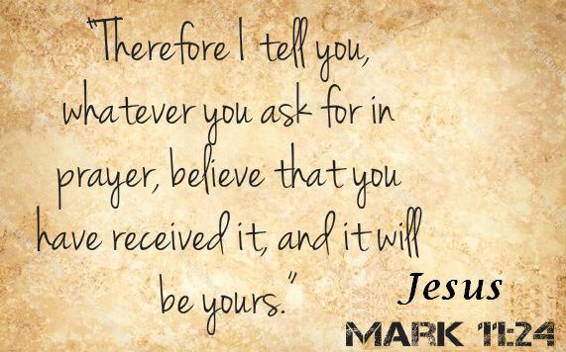
November 3, 2019
- Call to Worship
- Hymn
- Announcements
- Prayer Requests
- Music
- Sermon
- Communion
- Offering (on table)
From the Pastor
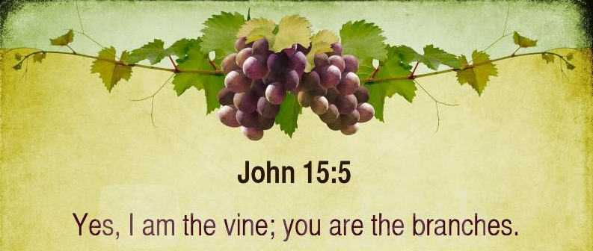
Proverbs 15:9 says, “The LORD detests the way of the wicked, but he loves those who pursue righteousness.” We pursue righteousness when we pursue the character of Christ, desiring holiness more than fleshly indulgence. We avoid pride and self-righteousness when we understand that true righteousness begins with godly humility (Psalm 25:90), remembering that Jesus said, “Apart from me you can do nothing” (John 15:5). Pursuing righteousness begins when a humble heart seeks the continual presence of God (James 4:10; 1 Peter 5:6); the humble, believing heart leading to a lifestyle of righteous actions and reactions acceptable to God (Psalm 51:10).
Pastor Tony

Church Information
Last Week’s giving: $ 180 Month to date: $ 4,300
Weekly Goal: $ 1,200 Previous month: $ 3,607
2019 Weekly Average: $ 1,098
Elders
Tony Raker (Pastor)..……………………........... tonyraker@yahoo.com
Delmas (Moe) Ritenour….………………………….. moemar@shentel.net
Finance: Linda Fraley ……………………………….. lindaf12@shentel.net

IT & Media: Rob Moses & Scott Tucker
Bulletin: Rob Moses ………………. admin@graceevfreechurchva.org
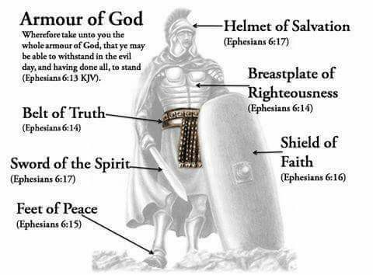
Breakfast: Tammy Copeland ……….…tammyscopeland@gmail.com
Grace Evangelical Free Church
718 E Queen Street, Strasburg, VA 22657, 540-465-4744 msg ph
https://graceevfreechurchva.org
Please turn off or mute cell phones
Notes:

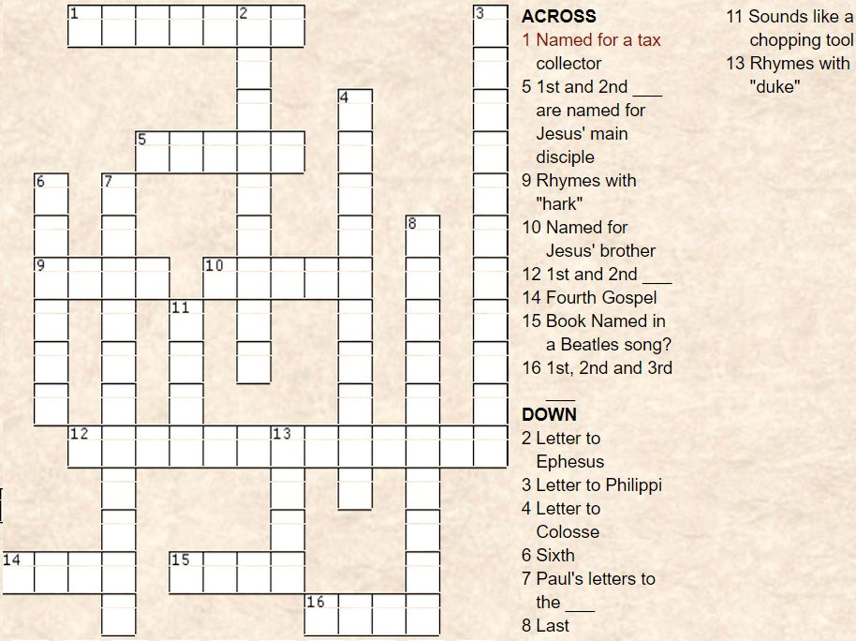
How well do you know the New Testament Books?

