Today’s Service
Nov 15, 2020
- Call to Worship
- Hymn
- Announcements
- Prayer Requests
- Music
- Sermon
- Offering (on table)
From the Pastor
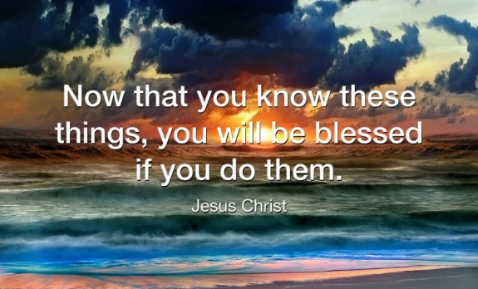
Why is obedience to God important? Specifically, obedience to God proves our love for Him (1 John 5:2-3), demonstrates our faithfulness to Him (1 John 2:3-6), glorifies Him in the world (1 Peter 2:12) and opens avenues of blessing for us (John 13:17). But what of sin in my life? Conviction can only come from the Holy Spirit (John 16:8) Who prompts us to acknowledge and ask for forgiveness. As is everything in the economy of God, He is glorified when He extends forgiveness, because it is written, “I will put my laws in their hearts, and I will write them on their minds. . . . Their sins and lawless acts I will remember no more” (Hebrews 10:16-17).
Pastor Tony
Church Information
Last Week’s giving:
$1,610 + Online: $300 = $1,910
Elders
Tony Raker (Pastor)..………………. pastor@graceevfreechurchva.org
Delmas (Moe) Ritenour….………………………….. moemar@shentel.net
Finance: Linda Fraley ……………………………….. lindaf12@shentel.net

IT & Media: Rob Moses & Scott Tucker
Bulletin: Rob Moses ………………. admin@graceevfreechurchva.org
Breakfast: Tammy Copeland ……….…tammyscopeland@gmail.com

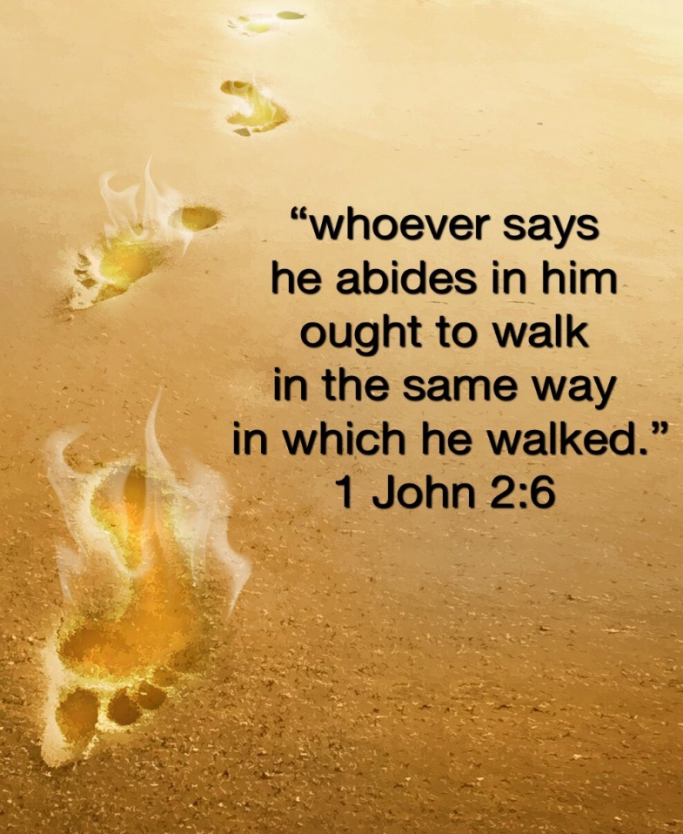
718 E Queen Street, Strasburg, VA 22657, 540-465-4744 msg ph
https://graceevfreechurchva.org
Please turn off or mute cell phones
Notes:

Instead of complaining about being tested,
ask God for the lesson He is teaching you.
