Today’s Service
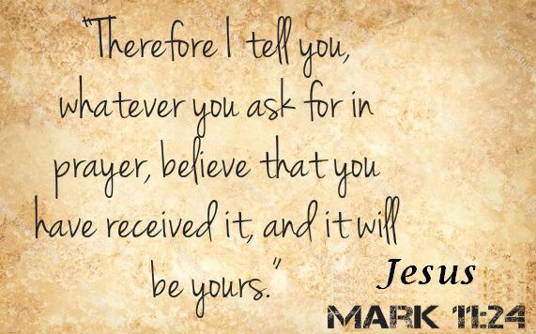
November 17, 2019
- Call to Worship
- Hymn
- Announcements
- Prayer Requests
- Music
- Sermon
- Offering (on table)
From the Pastor
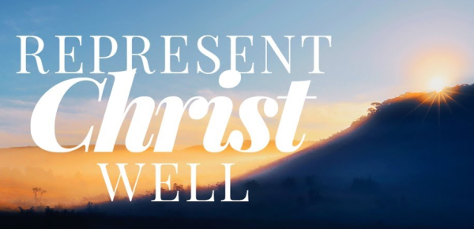
Those who claim to be the most tolerant are often the least tolerant of the Christian worldview. When a believer finds that his Christian convictions are in conflict with someone’s take on tolerance, we should immediately do the following things: 1) Pray for wisdom and for courage. 2) Examine our convictions to make sure they are biblical rather than personal preferences. 3) Commit ourselves to loving our enemies and doing good to them (Mt. 5:38–48). 4) Purpose in our hearts to engage the conflict “with compassion, kindness, humility, gentleness and patience” (Col. 3:12). 5) If legal issues come into play, explore our rights under the law (see Acts 16:37–38; 21:39). The point is to represent Christ in all aspects – uncompromising in conviction and mercy, wise as serpents and harmless as doves (Mt. 10:16).
Pastor Tony

Church Information
Last Week’s giving: $ 3,055 Month to date: $ 3,738
Weekly Goal: $ 1,200 Previous month: $ 4,300
2019 Weekly Average: $ 1,133
Elders
Tony Raker (Pastor)..……………………........... tonyraker@yahoo.com
Delmas (Moe) Ritenour….………………………….. moemar@shentel.net
Finance: Linda Fraley ……………………………….. lindaf12@shentel.net

IT & Media: Rob Moses & Scott Tucker
Bulletin: Rob Moses ………………. admin@graceevfreechurchva.org
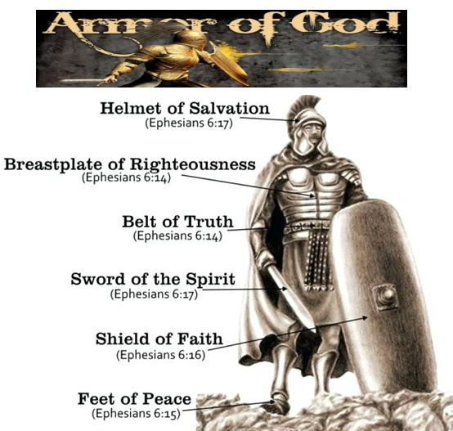
Breakfast: Tammy Copeland ……….…tammyscopeland@gmail.com
Grace Evangelical Free Church
718 E Queen Street, Strasburg, VA 22657, 540-465-4744 msg ph
https://graceevfreechurchva.org
Please turn off or mute cell phones
Notes:

