Today’s Service
Nov 29, 2020
- Call to Worship
- Hymn
- Announcements
- Prayer Requests
- Music
- Sermon
- Offering (on table)
From the Pastor
Proverbs 16:3 states, “Commit your work to the LORD, and your plans will be established.” The verb “commit” in Hebrew literally means “to roll.” The idea is that we completely give something over to God in dependence upon Him as we seek and follow His will. The Hebrew syntax also reveals the idea that as we commit our work to the Lord, our plans will be established. We must do the first part if we expect God to fulfill the second part. If we completely depend upon God in our work, He will “establish” our plans. That is, He will “bring about” or “cause to happen” our plans for our fulfillment as His servants for the advancement of His Kingdom.
Pastor Tony
Church Information
Last Week’s giving:
$2,921 + Online: $300 = $3,221
Elders
Tony Raker (Pastor)..………………. pastor@graceevfreechurchva.org
Delmas (Moe) Ritenour….………………………….. moemar@shentel.net
Finance: Linda Fraley ……………………………….. lindaf12@shentel.net

IT & Media: Rob Moses & Scott Tucker
Bulletin: Rob Moses ………………. admin@graceevfreechurchva.org
Breakfast: Tammy Copeland ……….…tammyscopeland@gmail.com
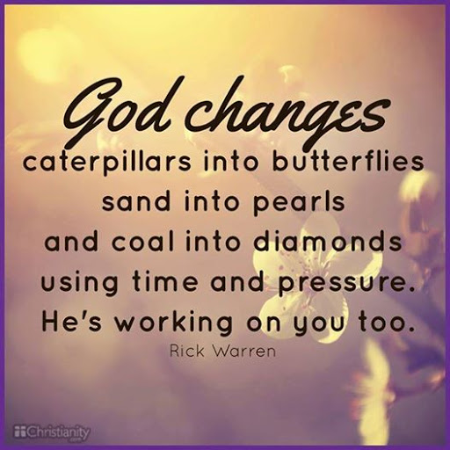
718 E Queen Street, Strasburg, VA 22657, 540-465-4744 msg ph
https://graceevfreechurchva.org
Please turn off or mute cell phones
Notes:

