Today’s Service
Nov 8, 2020
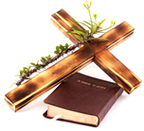
- Call to Worship
- Hymn
- Announcements
- Prayer Requests
- Music
- Sermon
- Offering (on table)
From the Pastor
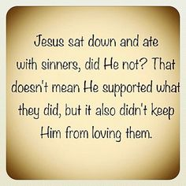
Spiritual discernment, or ‘wisdom’, is the ability to tell the difference between truth and error which, in turn, is critical to our walk with and for God. Hebrews 5:11-14 shows how spiritual discernment is developed: by studying and becoming ‘skilled’ in the Word of God (by which we define righteousness) and “constant practice” (through which we gain experience). By knowing and obeying the Word of God, we will be “trained by constant practice to distinguish good from evil;” able to discern the voice of the world from the voice of God, which helps us fend off temptation and allows us to “hate what is evil; cling to what is good” (Romans 12:9).
Pastor Tony
Church Information
Last Week’s giving:
$1,166 + Online: $500 = $1,666
Elders
Tony Raker (Pastor)..………………. pastor@graceevfreechurchva.org
Delmas (Moe) Ritenour….………………………….. moemar@shentel.net
Finance: Linda Fraley ……………………………….. lindaf12@shentel.net

IT & Media: Rob Moses & Scott Tucker
Bulletin: Rob Moses ………………. admin@graceevfreechurchva.org
Breakfast: Tammy Copeland ……….…tammyscopeland@gmail.com
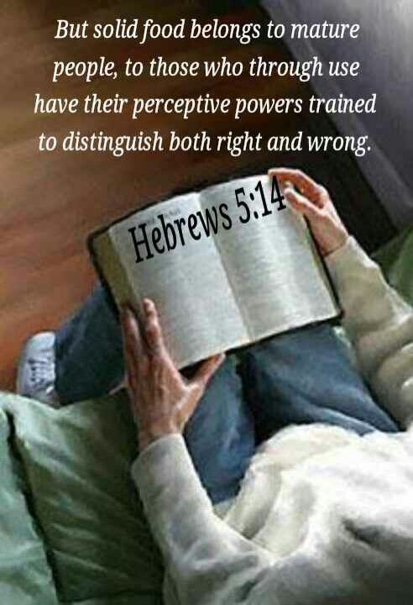

718 E Queen Street, Strasburg, VA 22657, 540-465-4744 msg ph
https://graceevfreechurchva.org
Please turn off or mute cell phones
Notes:

