Today’s Service
Dec 13, 2020
- Call to Worship
- Hymn
- Announcements
- Prayer Requests
- Music
- Sermon
- Offering (on table)
From the Pastor
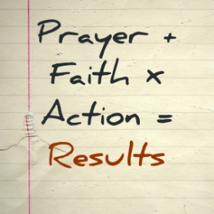
Jesus said, “Ask and you will receive, and your joy will be complete” (John 16:24). Among the most important prayers in the life of a Christian are “Teach me to love you above all else” and “Cause me to want what you want.” When we truly desire God, when we are passionate to see His will accomplished in this world, and when we ask for what brings Him glory, He is eager to give us anything we ask. Sometimes the things that glorify God are pleasant—a marriage or a child. Sometimes they are difficult for us—a failure that humbles us or a physical weakness that makes us more dependent upon God (see 2 Corinthians 12:7). But, when we pray within His will, in the authority of Jesus, persistently, unselfishly, and in faith, we will receive what we need. Pastor Tony
Church Information
Last Week’s giving:
$2,531 + Online: $1,200 = $3,731
Elders
Tony Raker (Pastor)..………………. pastor@graceevfreechurchva.org
Delmas (Moe) Ritenour….………………………….. moemar@shentel.net
Finance: Linda Fraley ……………………………….. lindaf12@shentel.net

IT & Media: Rob Moses & Scott Tucker
Bulletin: Rob Moses ………………. admin@graceevfreechurchva.org
Breakfast: Tammy Copeland ……….…tammyscopeland@gmail.com
718 E Queen Street, Strasburg, VA 22657, 540-465-4744 msg ph
https://graceevfreechurchva.org
Please turn off or mute cell phones
Notes:

