Today’s Service
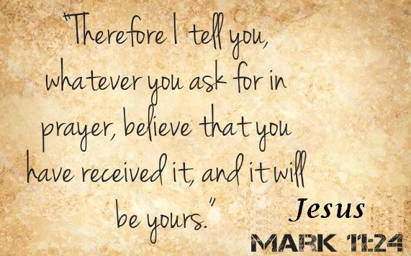
December 15, 2019
- Call to Worship
- Hymn
- Announcements
- Prayer Requests
- Music
- Sermon
- Offering (on table)
From the Pastor
If we love God, we will obey Him. We won’t be perfect in our perseverance, but our desire is to submit to the Lord and display good works. When we love God and obey Him, we naturally have love for one another. Obedience to God’s commands will make us light and salt in a dark and tasteless world (Matthew 5:13–16). In fact, perseverance is an essential part of the Christian faith. The Bible says that we show our love for Jesus by obeying Him in all things: “If you love Me, keep My commandments” (John 14:15). A Christian who is not obeying Christ’s commands can rightly be asked, “Why do you call me, ‘Lord, Lord,’ and do not do what I say?” (Luke 6:46).
Pastor Tony

Church Information
Last Week’s giving: $ 50 Month to date: $ 50
Weekly Goal: $ 1,200 Previous month: $ 4,998
2019 Weekly Average: $ 1,089
Elders
Tony Raker (Pastor)..……………………........... tonyraker@yahoo.com
Delmas (Moe) Ritenour….………………………….. moemar@shentel.net
Finance: Linda Fraley ……………………………….. lindaf12@shentel.net

IT & Media: Rob Moses & Scott Tucker
Bulletin: Rob Moses ………………. admin@graceevfreechurchva.org
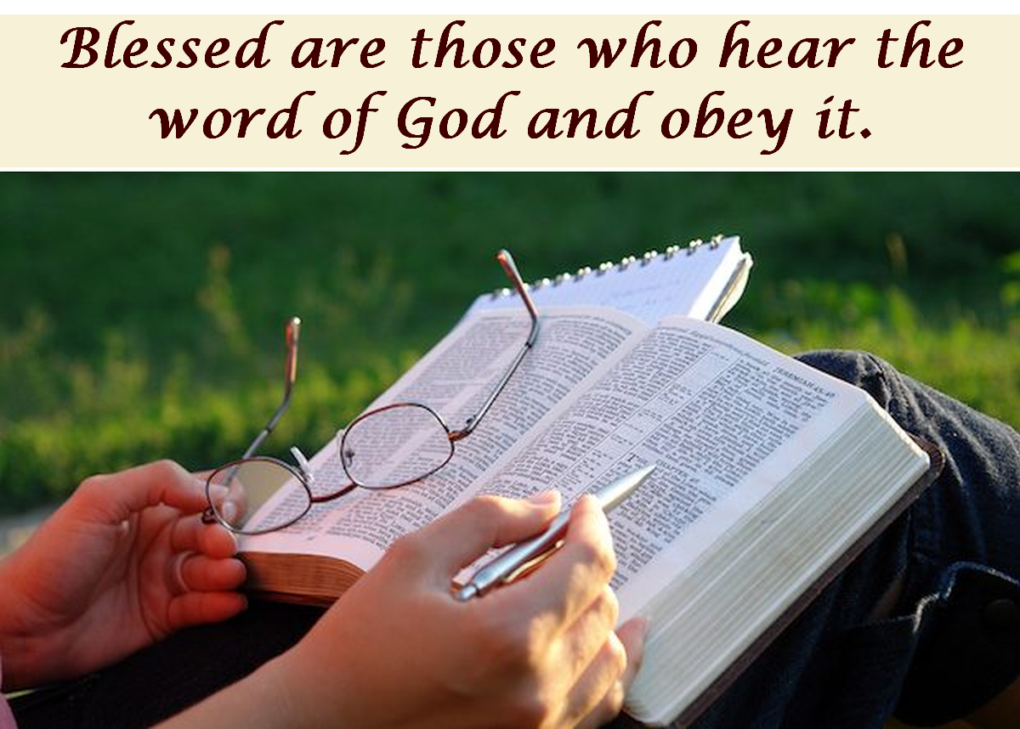
Breakfast: Tammy Copeland ……….…tammyscopeland@gmail.com
Grace Evangelical Free Church
718 E Queen Street, Strasburg, VA 22657, 540-465-4744 msg ph
https://graceevfreechurchva.org
Please turn off or mute cell phones
Notes:

