 **Today’s Service**

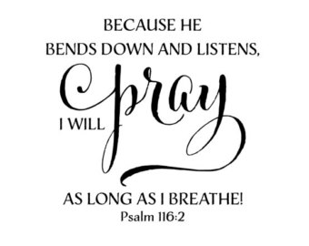 **Dec 16, 2018**

1. Call to Worship
2. Hymn
3. Announcements
4. Prayer Requests
5. Music
6. Sermon
7. Offering

**From the Pastor**

After Jesus rose from the dead, He "**presented Himself alive**" (**Acts 1:3**) to the women near the tomb (**Mt. 28:9-10**), to His disciples (**Lk. 24:36-43**), and to more than 500 others (**1 Cor. 15:6**).  In the days following His resurrection, Jesus taught His disciples about the kingdom of God (**Acts 1:3**).  Forty days after the resurrection, Jesus ascended literally, bodily to heaven.  The Scriptures frequently picture Him at the right hand of the Father-a position of honor and authority (**Ps. 110:1**; **Eph. 1:20**; **Heb. 8:1**). Christ is the Head of the Church (**Col. 1:18**), the giver of spiritual gifts (**Eph. 4:7-8**), and the One who fills all in all (**Eph. 4:9-10**).

Pastor Tony

**Church Information**

Last Week’s giving: $ 1,184 Month to date: $ 3,084

Weekly Goal: $ 875 Previous month: $ 5,239

Weekly Average: & 819 Monthly Goal: $ 3,500

**Elders**

Tony Raker (Pastor)..……………………........... [tonyraker@yahoo.com](mailto:tonyraker@yahoo.com)

Delmas (Moe) Ritenour ………………………….. [moemar@shentel.net](mailto:moemar@shentel.net)

Finance: Anthony Sinecoff………………………….. [sinecoff@gmail.com](mailto:sinecoff@gmail.com)

Linda Fraley ……………………………….. [lindaf12@shentel.net](mailto:lindaf12@shentel.net)

### Media: Rob Moses, Scott Tucker, & Tammy Copeland

Bulletin: Rob Moses ………………. [admin@graceevfreechurchva.org](mailto:admin@graceevfreechurchva.org)

Breakfast: Tammy Copeland ……….…[tammyscopeland@gmail.com](mailto:tammyscopeland@gmail.com)

Adult Sunday School 9:45 am…………………………………….. Linda Fraley



Grace Evangelical Free Church

718 E Queen Street, Strasburg, VA 22657, 540-465-4744 msg ph

<https://graceevfreechurchva.org>

Please put cell phones on vibrate

Notes:

**Next Breakfast is January 19th.**

Forbidden fruit creates many jams

