Today’s Service
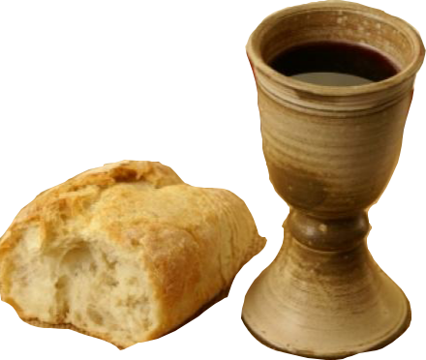
Dec 2, 2018
- Call to Worship
- Hymn
- Announcements
- Prayer Requests
- Music
- Sermon
- Communion
- Offering
From the Pastor
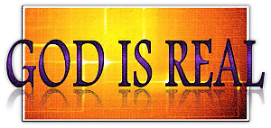
We know that God is real because He has revealed Himself to us in three ways: in creation, in His Word, and in His Son, Jesus Christ. The most basic proof of God's existence is simply what He has made: "The heavens declare the glory of God; the skies proclaim the work of his hands." (Psalm 19:1). God has also revealed Himself to us through His Word, the Bible. Throughout Scripture, the existence of God is treated as a self-evident fact (Genesis 1:1; Exodus 3:14). The third way in which God revealed Himself is through His Son, Jesus Christ (John 14:6-11). The historical record abounds with "proof" of who Jesus is. As the Apostle Paul said, this thing "was not done in a corner" (Acts 26:26).
Pastor Tony
Church Information
Last Week’s giving: $ 1,515 Month to date: $ 5,239
Weekly Goal: $ 875 Previous month: $ 1,192
Weekly Average: & 788 Monthly Goal: $ 3,500
Elders
Tony Raker (Pastor)..……………………........... tonyraker@yahoo.com
Delmas (Moe) Ritenour ………………………….. moemar@shentel.net
Finance: Anthony Sinecoff………………………….. sinecoff@gmail.com
Linda Fraley ……………………………….. lindaf12@shentel.net

Media: Rob Moses, Scott Tucker, & Tammy Copeland
Bulletin: Rob Moses ………………. admin@graceevfreechurchva.org
Breakfast: Tammy Copeland ……….…tammyscopeland@gmail.com
Adult Sunday School 9:45 am…………………………………….. Linda Fraley
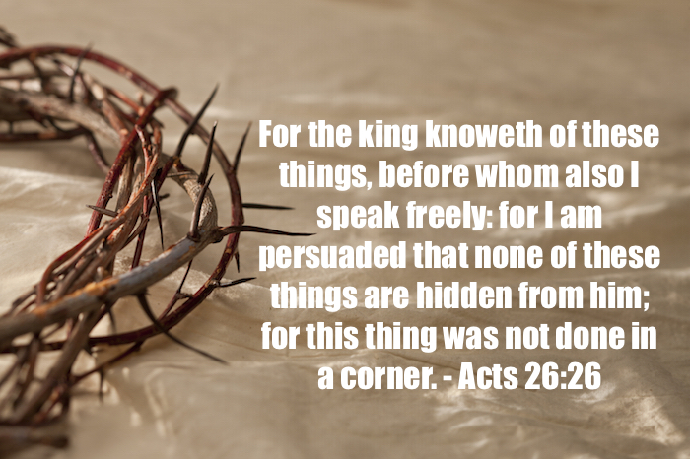
Grace Evangelical Free Church
718 E Queen Street, Strasburg, VA 22657, 540-465-4744 msg ph
https://graceevfreechurchva.org
Please put cell phones on vibrate
Notes:
.

Sorrow looks back, worry looks around, faith looks up
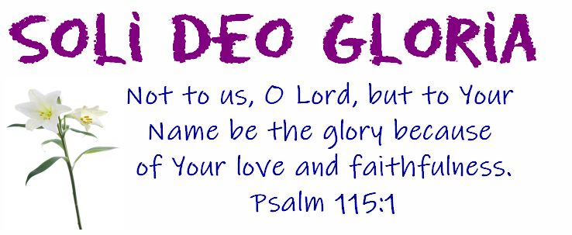
Next Breakfast is January 19th

