Today’s Service
Dec 27, 2020
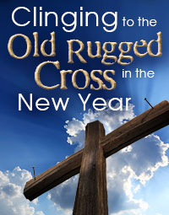
- Call to Worship
- Hymn
- Announcements
- Prayer Requests
- Music
- Sermon
- Offering (on table)
From the Pastor
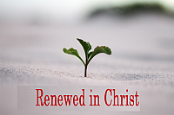
When we trust in Christ’s saving work we become a “new creation” (2 Cor. 5:17). The sins of one’s past are covered by the blood of Christ. In Christ, our sins are both forgiven and forgotten (Jeremiah 31:34; Hebrews 8:12; 10:17). God’s saving grace should humble us, and motivate us to serve Him, knowing that whatever He achieves though us is to His glory and praise. It should also encourage others by giving them hope of being useful in God’s service regardless of past sins: “For the death he died, he died to sin once for all, but the life he lives, he lives to God. 11 So you too consider yourselves dead to sin, but alive to God in Christ Jesus” (Romans 6:10-11).
Pastor Tony
Church Information
Last Week’s giving:
$1500 + Online: $40 = $1540
Elders
Tony Raker (Pastor)..………………. pastor@graceevfreechurchva.org
Delmas (Moe) Ritenour….………………………….. moemar@shentel.net
Finance: Linda Fraley ……………………………….. lindaf12@shentel.net

IT & Media: Rob Moses & Scott Tucker
Bulletin: Rob Moses ………………. admin@graceevfreechurchva.org
Breakfast: Tammy Copeland ……….…tammyscopeland@gmail.com
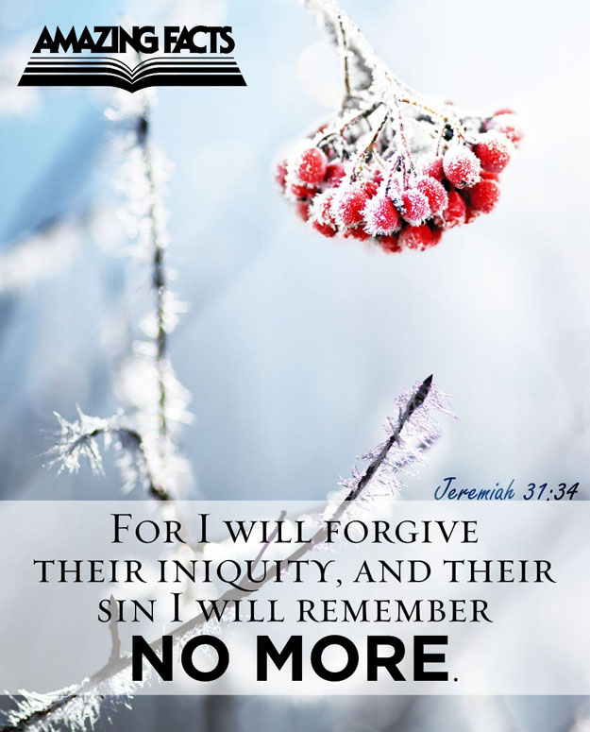
718 E Queen Street, Strasburg, VA 22657, 540-465-4744 msg ph
https://graceevfreechurchva.org
Please turn off or mute cell phones
Notes:

