Today’s Service
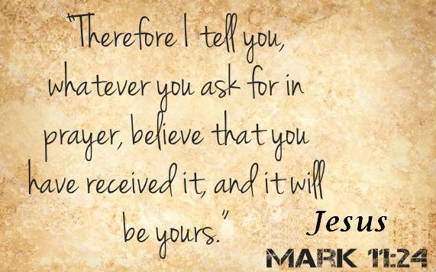
December 8, 2019
- Call to Worship
- Hymn
- Announcements
- Prayer Requests
- Music
- Sermon
- Offering (on table)
From the Pastor
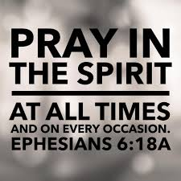
For the Christian, praying is supposed to be like breathing, easier to do than to not do. We pray for a variety of reasons. For one thing, prayer is a form of serving God (Luke 2:36-38) and obeying Him. God intends prayer to be the means of obtaining His solutions in a number of situations. We pray in preparation for major decisions (Luke 6:12-13); to overcome demonic barriers (Matthew 17:14-21); to gather workers for the spiritual harvest (Luke 10:2); to gain strength to overcome temptation (Matthew 26:41); and to obtain the means of strengthening others spiritually (Ephesians 6:18-19). May God find us often before His throne.
Pastor Tony

Church Information
Last Week’s giving: $ 50 Month to date: $ 50
Weekly Goal: $ 1,200 Previous month: $ 4,998
2019 Weekly Average: $ 1,089
Elders
Tony Raker (Pastor)..……………………........... tonyraker@yahoo.com
Delmas (Moe) Ritenour….………………………….. moemar@shentel.net
Finance: Linda Fraley ……………………………….. lindaf12@shentel.net

IT & Media: Rob Moses & Scott Tucker
Bulletin: Rob Moses ………………. admin@graceevfreechurchva.org
Breakfast: Tammy Copeland ……….…tammyscopeland@gmail.com
Grace Evangelical Free Church
718 E Queen Street, Strasburg, VA 22657, 540-465-4744 msg ph
https://graceevfreechurchva.org
Please turn off or mute cell phones
Notes:

