Today’s Service
Feb 10, 2019
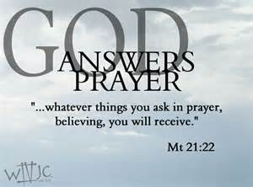
- Call to Worship
- Hymn
- Announcements
- Prayer Requests
- Music
- Sermon
- Offering
From the Pastor
When the Bible speaks of "walking," it often refers to a lifestyle. To walk with God means we choose to glorify Him in every way we can, regardless of personal cost. And there is a cost. Walking with God also means we cannot also walk with evil people as companions (Ps. 1:1-3). We choose the narrow road over the broad way to destruction (Mt. 7:13-14). We don't live to please our sinful flesh (Rm. 13:14). We seek to eliminate from our lives everything that does not enhance our walk with Him (Heb. 12:2). We can walk in the ways of the world as well (2 Kings 8:27; Eph. 2:2; Col. 3:7) which proves a repudiation of God (James 4:4-5).
Pastor Tony
Church Information
Last Week’s giving: $ 1,980 Month to date: $ 1,980
Weekly Goal: $ 875 Previous month: $ 4,053
2019 Weekly Average: $ 1,207 Monthly Goal: $ 3,500
Elders
Tony Raker (Pastor)..……………………........... tonyraker@yahoo.com
Delmas (Moe) Ritenour ………………………….. moemar@shentel.net
Finance: Anthony Sinecoff………………………….. sinecoff@gmail.com
Linda Fraley ……………………………….. lindaf12@shentel.net

Media: Rob Moses & Scott Tucker
Bulletin: Rob Moses ………………. admin@graceevfreechurchva.org
Breakfast: Tammy Copeland ……….…tammyscopeland@gmail.com
Adult Sunday School 9:45 am…………………………………….. Linda Fraley
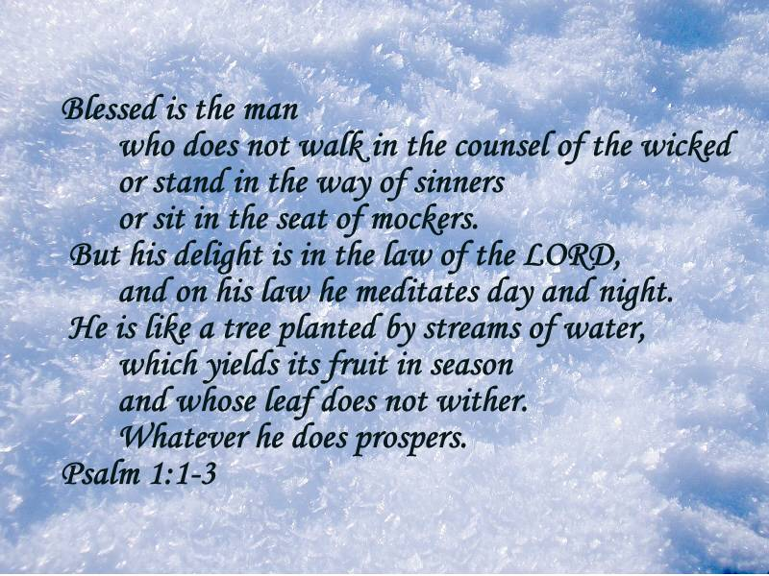
Grace Evangelical Free Church
718 E Queen Street, Strasburg, VA 22657, 540-465-4744 msg ph
https://graceevfreechurchva.org
Please turn off or mute cell phones
Notes:

Next Breakfast is February 16th.

God helps those who help others 