Today’s Service
Feb 17, 2019
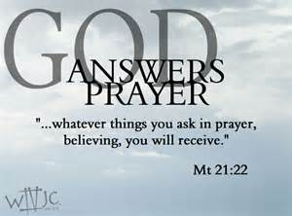
- Call to Worship
- Hymn
- Announcements
- Prayer Requests
- Music
- Sermon
- Offering
From the Pastor
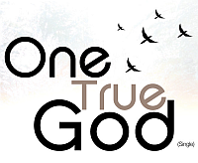
The godless person is not a person who has no god, for everyone has gods, including the atheist. A god is simply that which a person elevates to the position of greatest importance and significance. For some people this is the One True God or some pagan god, and for others it may be family, wealth, prestige, scientific materialism, or personal autonomy. Everyone has gods, even the godless, but only believers in Christ know and revere the One True God as He has revealed Himself in Scripture, who’s way is perfect and word is true (2 Samuel 22:31).
Pastor Tony
Church Information
Last Week’s giving: $ 980 Month to date: $ 2,960
Weekly Goal: $ 875 Previous month: $ 4,053
2019 Weekly Average: $ 1,169 Monthly Goal: $ 3,500
Elders
Tony Raker (Pastor)..……………………........... tonyraker@yahoo.com
Delmas (Moe) Ritenour ………………………….. moemar@shentel.net
Finance: Anthony Sinecoff………………………….. sinecoff@gmail.com
Linda Fraley ……………………………….. lindaf12@shentel.net

Media: Rob Moses & Scott Tucker
Bulletin: Rob Moses ………………. admin@graceevfreechurchva.org
Breakfast: Tammy Copeland ……….…tammyscopeland@gmail.com
Adult Sunday School 9:45 am…………………………………….. Linda Fraley
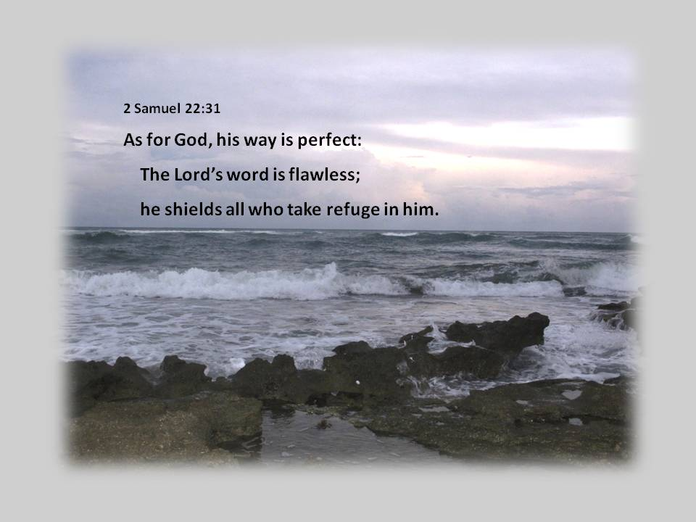
Grace Evangelical Free Church
718 E Queen Street, Strasburg, VA 22657, 540-465-4744 msg ph
https://graceevfreechurchva.org
Please turn off or mute cell phones
Notes:

Next Breakfast is March 16th.

A clear conscience makes a soft pillow 