Today’s Service
Feb 21, 2021
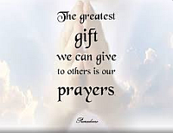
- Call to Worship
- Hymn
- Announcements
- Prayer Requests
- Special Music
- Sermon
From the Pastor
When we start to experience fear, we know it’s time to put our trust in God (Psalm 56:3). As we turn to Him in prayer, He will free us from fear and fill us with His supernatural peace (Psalm 34:4; Philippians 4:6). In our darkest, most trying times, we must remember that God is near (Psalm 34:18). He is our Shepherd, and we are in His constant care. Throughout our lives and even in death, His goodness and love will never fail us (Psalm 23:6). Only when we are secure in the knowledge that our Good Shepherd is with us can we confidently say, “I will fear no evil.”
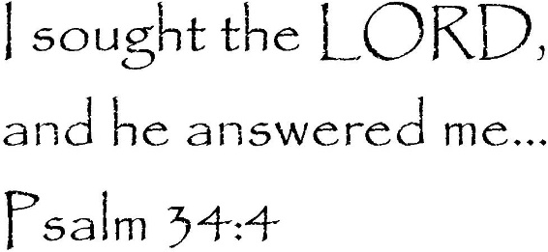
Pastor Tony
Church Information
Last Week’s giving:
$850 + Online: $300 = $1,150
Elders
Tony Raker (Pastor)..………………. pastor@graceevfreechurchva.org
Delmas (Moe) Ritenour….………………………….. moemar@shentel.net
Finance: Linda Fraley ……………………………….. lindaf12@shentel.net

IT & Media: Rob Moses & Scott Tucker
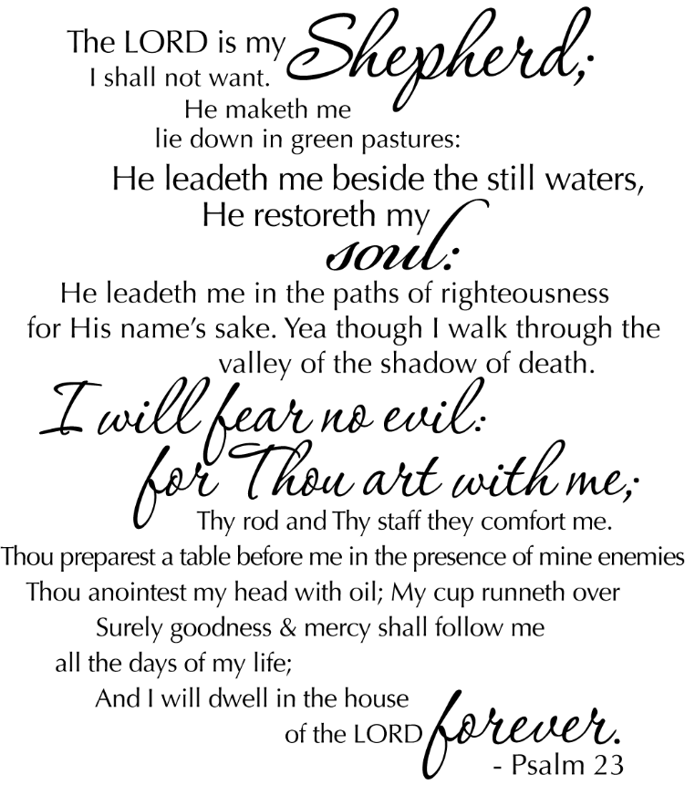
Bulletin: Rob Moses ………………. admin@graceevfreechurchva.org
Breakfast: Tammy Copeland ……….…tammyscopeland@gmail.com
718 E Queen Street, Strasburg, VA 22657, 540-465-4744 msg ph
https://graceevfreechurchva.org
Notes:
Business meeting March 6th

