Today’s Service
Feb 28, 2021
- Call to Worship
- Hymn
- Announcements
- Prayer Requests
- Special Music
- Sermon
From the Pastor
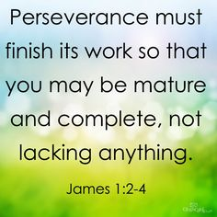
James 1:2 contains the clause count it all joy. It is the first command James gives in his epistle. To understand what he means by it, the translation of James 1:2–4 by J.B. Phillips aids our understanding: “When all kinds of trials and temptations crowd into your lives my brothers, don’t resent them as intruders, but welcome them as friends! Realize that they come to test your faith and to produce in you the quality of endurance. But let the process go on until that endurance is fully developed, and you will find you have become men of mature character with the right sort of independence.” In short, to count it all joy when we face trials, we must evaluate the difficulties in life with eyes of faith and see them in light of God’s good purpose.
Pastor Tony
Church Information
Last Week’s giving:
$2,675 + Online $300 = $2,375
Elders
Tony Raker (Pastor)..………………. pastor@graceevfreechurchva.org
Delmas (Moe) Ritenour….………………………….. moemar@shentel.net
Finance: Linda Fraley ……………………………….. lindaf12@shentel.net

IT & Media: Rob Moses & Scott Tucker
Bulletin: Rob Moses ………………. admin@graceevfreechurchva.org
Breakfast: Tammy Copeland ……….…tammyscopeland@gmail.com
718 E Queen Street, Strasburg, VA 22657, 540-465-4744 msg ph
https://graceevfreechurchva.org
Notes:
Business meeting Today after church

