Today’s Service
Feb 3, 2019
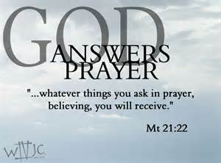
- Call to Worship
- Hymn
- Announcements
- Prayer Requests
- Music
- Sermon
- Communion
- Offering
From the Pastor
To “walk in the light” is a common metaphor within Christian culture, taken to mean “acting correctly” or even “living openly.” Biblically, however, the phrase has the idea of relinquishing sin by following Jesus who said, “I am the light of the world. He who follows me shall not walk in darkness, but have the light of life” (John 8:12). Our Christian duty is to live in the light God gives: “Now you are light in the Lord. Walk as children of light” (Eph. 5:8). Sin is left in the shadows as we let our light “shine before men” (Mt. 5:16). “Walking in the light” means we consider Jesus as “the light” in this world, and we “walk” in that light by following His precepts, living in His power, and growing in His grace.
Pastor Tony
Church Information
Last Week’s giving: $ 519 Month to date: $ 4,053
Weekly Goal: $ 875 Previous month: $ 4,940
2019 Weekly Average: $ 1,013 Monthly Goal: $ 3,500
Elders
Tony Raker (Pastor)..……………………........... tonyraker@yahoo.com
Delmas (Moe) Ritenour ………………………….. moemar@shentel.net
Finance: Anthony Sinecoff………………………….. sinecoff@gmail.com
Linda Fraley ……………………………….. lindaf12@shentel.net

Media: Rob Moses & Scott Tucker
Bulletin: Rob Moses ………………. admin@graceevfreechurchva.org
Breakfast: Tammy Copeland ……….…tammyscopeland@gmail.com
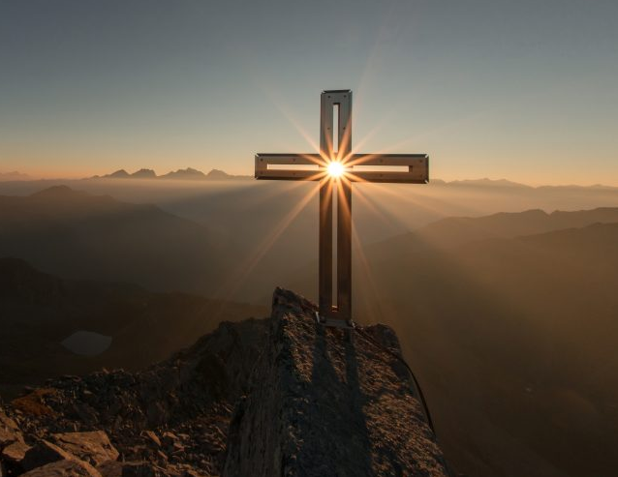
Adult Sunday School 9:45 am…………………………………….. Linda Fraley

Grace Evangelical Free Church
718 E Queen Street, Strasburg, VA 22657, 540-465-4744 msg ph
https://graceevfreechurchva.org
Please turn off or mute cell phones
Notes:

Next Breakfast is February 16th.

It’s hard to stumble when you’re on your knees

