Today’s Service
March 14, 2021
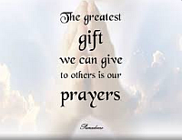
- Call to Worship
- Hymn
- Announcements
- Prayer Requests
- Special Music
- Sermon
From the Pastor
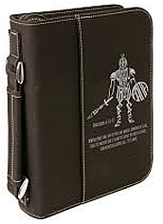
Ephesians 6:13-18 gives a description of the spiritual armor God gives us, standing firm with the belt of truth, buckle on the breastplate of righteousness, wear on our feet the gospel of peace, hold up the shield of faith, wear the helmet of salvation, and wield the sword of the Spirit, which is the Word of God—the only offensive weapon in the whole armory. We are to speak the truth against Satan’s lies. Assured we are declared righteous because of Christ’s sacrifice for us that no spiritual force can take away, we are to proclaim the gospel no matter how much resistance we encounter. We are not to waver in our faith, no matter how fiercely we are attacked. Our offensive weapon is the Word of God, not our own opinions and feelings. Finally, we are to follow Jesus’ example in recognizing that some spiritual victories are only possible through prayer.
Pastor Tony
Church Information
Last Week’s giving:
$1,916 + Online $300 = $2,216
Elders
Tony Raker (Pastor)..………………. pastor@graceevfreechurchva.org
Delmas (Moe) Ritenour….………………………….. moemar@shentel.net
Finance: Linda Fraley ……………………………….. lindaf12@shentel.net

IT & Media: Rob Moses & Scott Tucker
Bulletin: Rob Moses ………………. admin@graceevfreechurchva.org
Breakfast: Tammy Copeland ……….…tammyscopeland@gmail.com
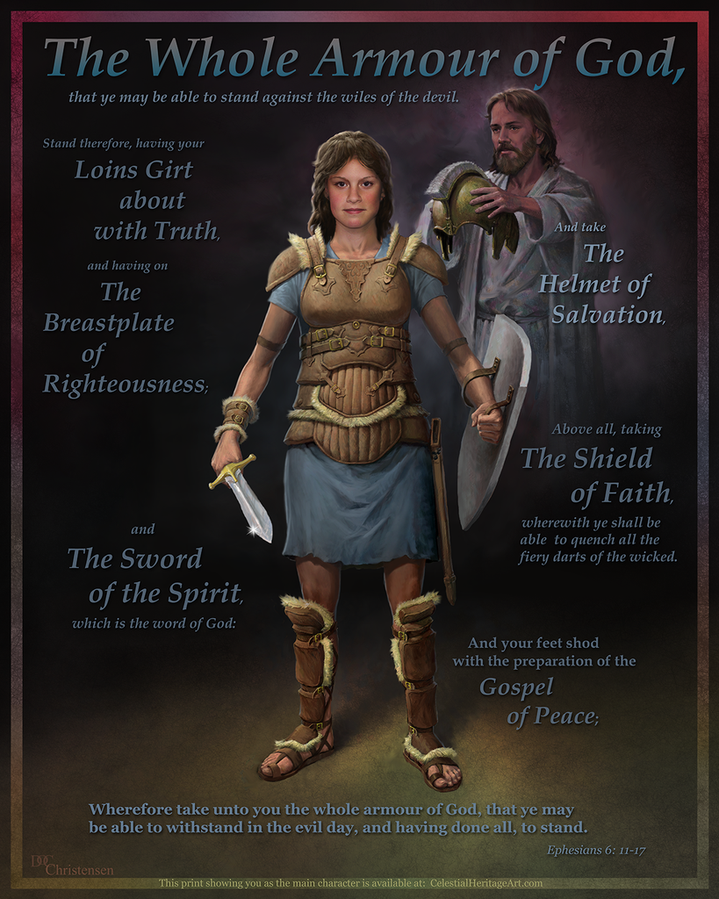
718 E Queen Street, Strasburg, VA 22657, 540-465-4744 msg ph
https://graceevfreechurchva.org
Notes:

