Today’s Service
March 25, 2018
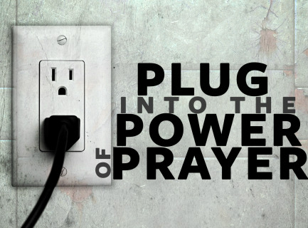
- Call to Worship
- Hymn
- Announcements
- Prayer Requests
- Music
- Sermon
- Offering

From the Pastor
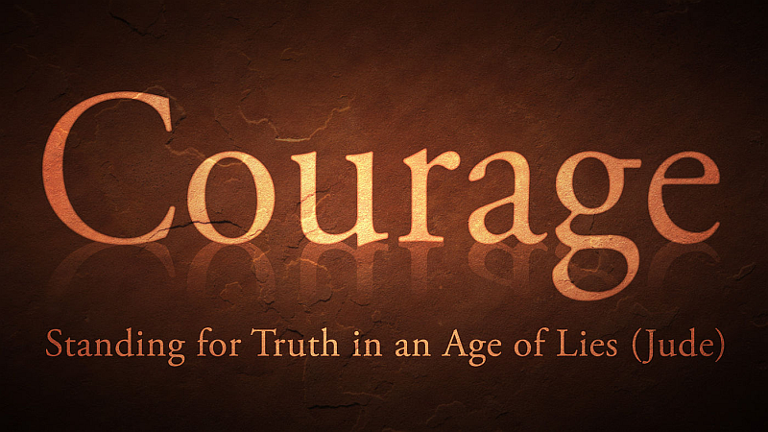
The Greek word translated “courage” and “good cheer” means literally “boldness and confidence.” We can be confident, courageous, and of good cheer because of Him. “Have no fear of sudden disaster or of the ruin that overtakes the wicked, for the LORD will be your confidence and will keep your foot from being snared” (Proverbs 3:25-26). Here is the promise of God’s superintending care for us, a care that is absent from the lives of those who reject Him. But for those who have placed their faith in Christ for salvation, we are to have no fear because “it is your Father’s good pleasure to give you the kingdom” (Luke 12:32). In this great promise lies the basis of our confidence, our courage, and our good cheer.
Pastor Tony
Church Information
Last Week’s giving: $ 110 Month to date: $ 2,400
Weekly Target: $ 875 Previous month: $ 1,634
Year to Date: $ 5,233 Monthly Target: $ 3,500
YTD target: $9,625 (-4,392) Building Fund: $ 10,580
Adult Sunday School 9:45 am………………………………….. Linda Fraley
Elders
Tony Raker (Pastor)..…………………........... tonyraker@yahoo.com
Delmas (Moe) Ritenour ……………………….. moemar@shentel.net
Finance: Anthony Sinecoff……………………….. sinecoff@gmail.com
Linda Fraley …………………………….. lindaf12@shentel.net

Media: Rob Moses, Scott Tucker, & Tammy Copeland
Bulletin: Rob Moses ……………. admin@graceevfreechurchva.org
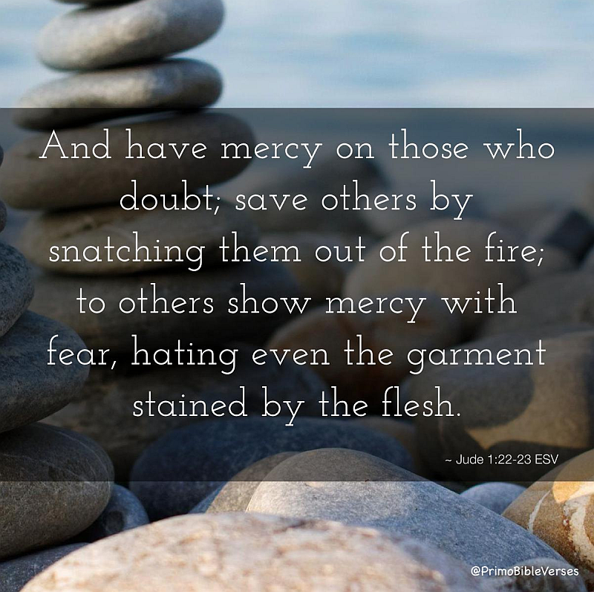
Tammy Copeland …………..……..… …tammyscopeland@gmail.com

Grace Evangelical Free Church
718 E Queen Street, Strasburg, VA 22657, 540-465-4744 msg ph
https://graceevfreechurchva.org
Please put cell phones on vibrate!
Notes:



