Today’s Service
March 28, 2021
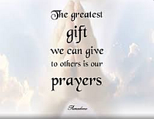
- Call to Worship
- Hymn
- Announcements
- Prayer Requests
- Special Music
- Sermon
From the Pastor
Passion Week is the time from Palm Sunday through Resurrection Sunday, entailing such memorable events as Jesus cleansing the Temple (Luke 19:45-46); disputing with the Pharisees regarding His authority; giving His Olivet Discourse on the end times; officiating the Last Supper (Luke 22:7-38); praying in the garden of Gethsemane. It was here that Jesus, having been betrayed by Judas, was arrested and taken to several sham trials before the chief priests, Pontius Pilate, and Herod (Luke 22:54-23:25). It is referred to as Passion Week because in that time, Jesus Christ truly revealed His passion for us in the suffering He willingly went through on our behalf. We should be passionate in our worship of Jesus and in our proclamation of His Gospel! As He suffered for us, so should we be willing to suffer for the cause of following Him and proclaiming the message of His death and resurrection.
Pastor Tony
Church Information
Last Week’s giving:
$1,300 + Online $0 = $1,300
Elders
Tony Raker (Pastor)..………………. pastor@graceevfreechurchva.org
Delmas (Moe) Ritenour….………………………….. moemar@shentel.net
Finance: Linda Fraley ……………………………….. lindaf12@shentel.net

IT & Media: Rob Moses & Scott Tucker
Bulletin: Rob Moses ………………. admin@graceevfreechurchva.org
Breakfast: Tammy Copeland ……….…tammyscopeland@gmail.com
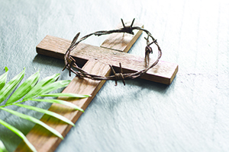
718 E Queen Street, Strasburg, VA 22657, 540-465-4744 msg ph
https://graceevfreechurchva.org
Notes:

