Today’s Service
March 3, 2019
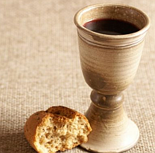
- Call to Worship
- Hymn
- Announcements
- Prayer Requests
- Music
- Sermon
- Communion
- Offering
From the Pastor
Our attitude toward the truth determines the outcome of our lives. It is possible for everyone to walk in the truth of Jesus (John 14:6), so that it can set us free from sin – both the consequences of it and its power over us (John 8:32). There is no reason to ever be discouraged when we see the truth about ourselves, no matter what we see: “And whoever has this hope in Him purifies himself, just as He is pure” (1 John 3:3). Therefore let Jesus, who is Truth, be our best friend!
Pastor Tony
Church Information
Last Week’s giving: $ 1,180 Month to date: $ 1,180
Weekly Goal: $ 875 Previous month: $ 4,220
2019 Weekly Average: $ 1,034 Monthly Goal: $ 3,500
Elders
Tony Raker (Pastor)..……………………........... tonyraker@yahoo.com
Delmas (Moe) Ritenour ………………………….. moemar@shentel.net
Finance: Anthony Sinecoff………………………….. sinecoff@gmail.com
Linda Fraley ……………………………….. lindaf12@shentel.net

Media: Rob Moses & Scott Tucker
Bulletin: Rob Moses ………………. admin@graceevfreechurchva.org
Breakfast: Tammy Copeland ……….…tammyscopeland@gmail.com
Adult Sunday School 9:45 am…………………………………….. Linda Fraley
Grace Evangelical Free Church
718 E Queen Street, Strasburg, VA 22657, 540-465-4744 msg ph
https://graceevfreechurchva.org
Please turn off or mute cell phones
Notes:

Next Breakfast is March 16th.

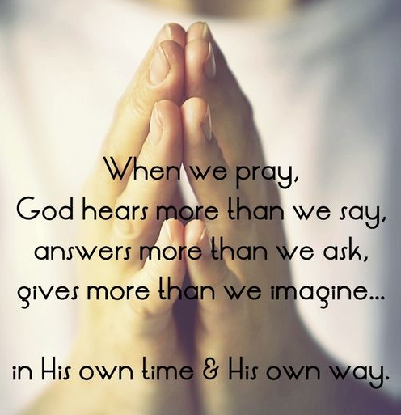
Life has many choices. Eternity has two. What’s yours?

