Today’s Service
April 11, 2021
- Call to Worship
- Hymn
- Announcements
- Prayer Requests
- Special Music
- Sermon
From the Pastor
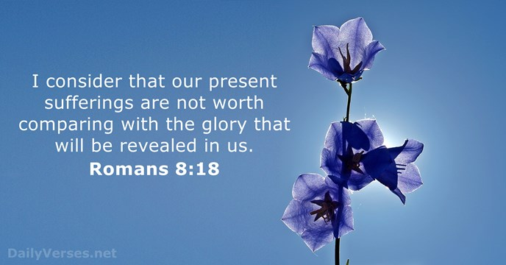
When we apply God’s Word to our daily lives, our consciences are clean and our lives function as they were designed to function. When we walk in fellowship with God, keeping our sins confessed and our lives free of besetting sins, we are rewarded daily with fruit from the Holy Spirit (Galatians 5:22–23), communion with God (James 4:7–8), and power to resist the attacks of Satan (Ephesians 6:10–17). Whatever struggles we face on earth in order to obey God’s Word will be overly compensated in eternity with rewards we cannot even imagine (Romans 8:18).
Pastor Tony
Church Information
Last Week’s giving:
$4,363 + Online $100 = $4,463
Elders
Tony Raker (Pastor)..………………. pastor@graceevfreechurchva.org
Delmas (Moe) Ritenour….………………………….. moemar@shentel.net
Finance: Linda Fraley ……………………………….. lindaf12@shentel.net

IT & Media: Rob Moses & Scott Tucker
Bulletin: Rob Moses ………………. admin@graceevfreechurchva.org
Breakfast: Tammy Copeland ……….…tammyscopeland@gmail.com
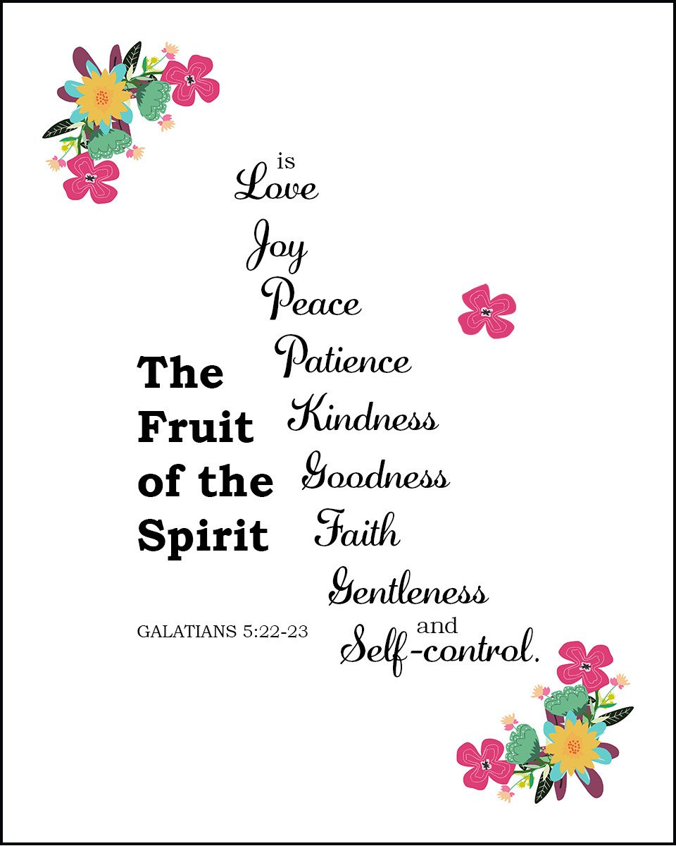
718 E Queen Street, Strasburg, VA 22657, 540-465-4744 msg ph
https://graceevfreechurchva.org
Notes:

