Today’s Service
April 14, 2019
- Call to Worship
- Hymn
- Announcements
- Prayer Requests
- Music
- Sermon
- Offering
From the Pastor
To be faithful is to be reliable, steadfast and unwavering, and the Bible speaks of this type of faithfulness in four ways: as an attribute of God (1 Kings 8:56); as a positive characteristic of some men (Nehemiah 7:2); as a characteristic that many men lack (Proverbs 20:6); and as a gift of the Holy Spirit (Galatians 5:22). Faithfulness affects every relationship we have – a direct reflection of the depth and degree of our relationship with God. Hence, the importance of our daily walk (Ephesians 5:2).
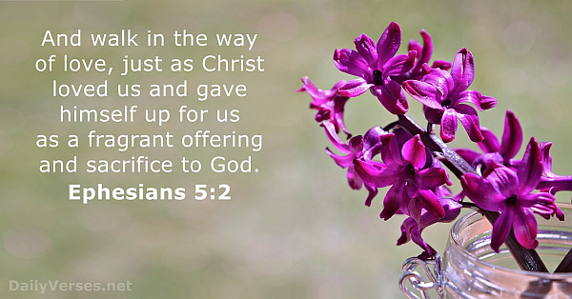
Pastor Tony
Church Information
Last Week’s giving: $ 1,000 Month to date: $ 1,000
Weekly Goal: $ 875 Previous month: $ 7,343
2019 Weekly Average: $ 1,187 Monthly Goal: $ 3,500
Elders
Tony Raker (Pastor)..……………………........... tonyraker@yahoo.com
Delmas (Moe) Ritenour ………………………….. moemar@shentel.net
Finance: Anthony Sinecoff………………………….. sinecoff@gmail.com
Linda Fraley ……………………………….. lindaf12@shentel.net

Media: Rob Moses & Scott Tucker
Bulletin: Rob Moses ………………. admin@graceevfreechurchva.org
Breakfast: Tammy Copeland ……….…tammyscopeland@gmail.com
Adult Sunday School 9:45 am…………………………………….. Linda Fraley

Grace Evangelical Free Church
718 E Queen Street, Strasburg, VA 22657, 540-465-4744 msg ph
https://graceevfreechurchva.org
Please turn off or mute cell phones
Notes:

Next Breakfast is April 20th.

