Today’s Service
April 25, 2021
- Call to Worship
- Hymn
- Announcements
- Prayer Requests
- Special Music
- Sermon
From the Pastor
Psalm 90:12 says, “Teach us to number our days, that we may gain a heart of wisdom.” The request “teach us to number our days” means that we need God to reveal to us the brevity of life. Those who have learned to number their days spend them in pursuit of wisdom, goodness, and the kingdom of God (Matthew 6:33). They don’t have to fear the wrath of God when their earthly lives are over. Those who never learn to number their days spend them as if this life is all there is. Psalm 90 warns them about the judgment they are destined to undergo (Hebrews 9:27). But when we learn to number our days, we see each day as a valuable gift and an opportunity to store up treasure in heaven (Luke 12:33; Revelation 22:12).

Pastor Tony
Church Information
Last Week’s giving:
$1,671+Online $0 = $1,671
Elders
Tony Raker (Pastor)..………………. pastor@graceevfreechurchva.org
Delmas (Moe) Ritenour………………………….. moemar@shentel.net
Finance: Linda Fraley ……………………………….. lindaf12@shentel.net

IT & Media: Rob Moses & Scott Tucker
Bulletin: Rob Moses ………………. admin@graceevfreechurchva.org
Breakfast: Tammy Copeland ……….…tammyscopeland@gmail.com
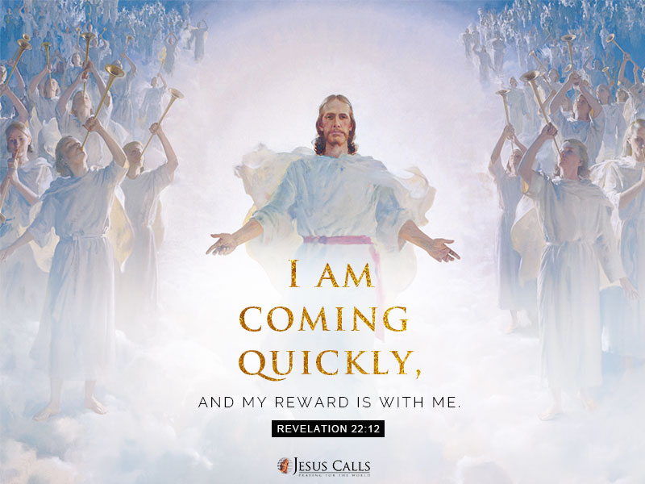
718 E Queen Street, Strasburg, VA 22657, 540-465-4744 msg ph
https://graceevfreechurchva.org
Notes:

