Today’s Service
April 7, 2019
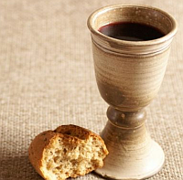
- Call to Worship
- Hymn
- Announcements
- Prayer Requests
- Music
- Sermon
- Communion
- Offering
From the Pastor
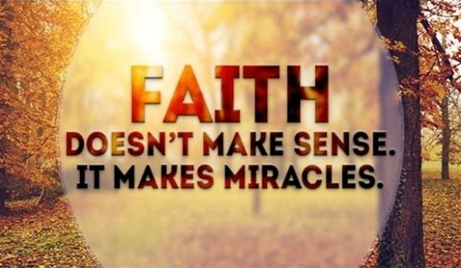
One of the greatest articulations of God’s love and sustaining power is: “If God is for us, who can be against us? He who did not spare His own Son, but gave Him up for us all – how will He not also, along with Him, graciously give us all things? Who shall separate us from the love of Christ? Shall trouble or hardship or persecution or famine or nakedness or danger or sword? . . . No, in all these things we are more than conquerors through Him who loved us. For I am convinced that neither death nor life, neither angels nor demons, neither the present nor the future, nor any powers, neither height nor depth, nor anything else in all creation, will be able to separate us from the love of God that is in Christ Jesus our Lord” (Romans 8:31-32, 35-39). Rely on God as our Redeemer; trust Him as our Defender; love Him unconditionally as He loves us!
Pastor Tony
Church Information
Last Week’s giving: $ 2,259 Month to date: $ 7,343
Weekly Goal: $ 875 Previous month: $ 4,220
2019 Weekly Average: $ 1,201 Monthly Goal: $ 3,500
Elders
Tony Raker (Pastor)..……………………........... tonyraker@yahoo.com
Delmas (Moe) Ritenour ………………………….. moemar@shentel.net
Finance: Anthony Sinecoff………………………….. sinecoff@gmail.com
Linda Fraley ……………………………….. lindaf12@shentel.net

Media: Rob Moses & Scott Tucker
Bulletin: Rob Moses ………………. admin@graceevfreechurchva.org
Breakfast: Tammy Copeland ……….…tammyscopeland@gmail.com
Adult Sunday School 9:45 am…………………………………….. Linda Fraley

Grace Evangelical Free Church
718 E Queen Street, Strasburg, VA 22657, 540-465-4744 msg ph
https://graceevfreechurchva.org
Please turn off or mute cell phones
Notes:

Next Breakfast is April 20th

