Today’s Service
May 12, 2019
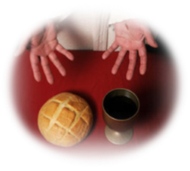
- Call to Worship
- Hymn
- Announcements
- Prayer Requests
- Music
- Sermon
- Communion
- Offering
From the Pastor
Our identity in Christ is first and foremost one of newness. We are new creations in Christ (2 Cor. 5:17), walking in the light of Christ (Eph. 5:8). We are no longer citizens of the world but apart from it (2 Cor. 6:14—7:1). We understand that we are a part of a heavenly, God-ruled kingdom. Things of the earth no longer draw us (Col. 3:2). We don’t fear or over-emphasize suffering on earth or the trials we face (Col. 1:24; 1 Pet. 3:14; 4:12–14), nor do we place importance on things the world values (1 Tim. 6:9–11). Even our bodies and our actions reflect that our minds are no longer conformed to the world (Rom. 12:1–2) but are now instruments of righteousness to God (Rom. 6:13). And our new kingdom perspective means we understand that our enemy is not the people around us but the spiritual forces that endeavor to keep the people from knowing God (Eph. 6:12). All of this is the ideal—the character of a mature believer walking in God’s light!

Pastor Tony
Church Information
Last Week’s giving: $ 1,930 Month to date: $ 1,930
Weekly Goal: $ 875 Previous month: $ 5,270
2019 Weekly Average: $ 1,268 Monthly Goal: $ 3,500
Elders
Tony Raker (Pastor)..……………………........... tonyraker@yahoo.com
Delmas (Moe) Ritenour ………………………….. moemar@shentel.net
Finance: Anthony Sinecoff………………………….. sinecoff@gmail.com
Linda Fraley ……………………………….. lindaf12@shentel.net

Media: Rob Moses & Scott Tucker
Bulletin: Rob Moses ………………. admin@graceevfreechurchva.org
Breakfast: Tammy Copeland ……….…tammyscopeland@gmail.com
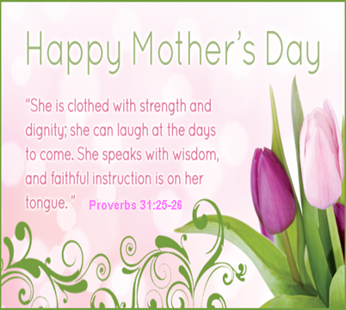
Adult Sunday School 9:45 am…………………………………….. Linda Fraley

Grace Evangelical Free Church
718 E Queen Street, Strasburg, VA 22657, 540-465-4744 msg ph
https://graceevfreechurchva.org
Please turn off or mute cell phones
Notes:

Next Breakfast is May 18th

