Today’s Service
May 19, 2019
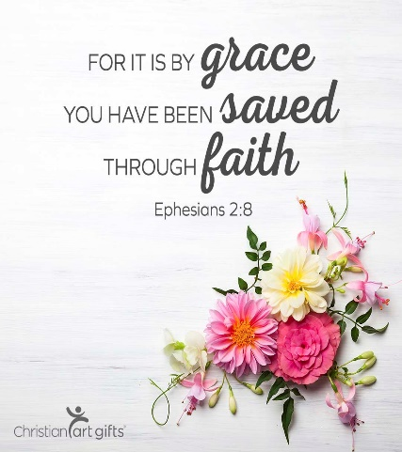
- Call to Worship
- Hymn
- Announcements
- Prayer Requests
- Music
- Sermon
- Communion
- Offering
From the Pastor
In the statement “be sure your sin will find you out” (Numbers 32:23) is revealed the mystery of sin. The nature of sin is such that, whether or not others discover your sin, your sin will “discover you.” You cannot run from the consequences, including God’s knowledge of your sin. Don’t even think about toying with sin. It cannot be tamed, outrun, or shaken off. No matter how safe you think you are, your sin will find you out. This is why 1 John 1:9 is so precious: “If we confess our sins, he is faithful and just to forgive us our sins and to cleanse us from all unrighteousness.”

Pastor Tony

Church Information
Last Week’s giving: $ 1,050 Month to date: $ 2,980
Weekly Goal: $ 875 Previous month: $ 5,270
2019 Weekly Average: $ 1,256 Monthly Goal: $ 3,500
Elders
Tony Raker (Pastor)..……………………........... tonyraker@yahoo.com
Delmas (Moe) Ritenour ………………………….. moemar@shentel.net
Finance: Anthony Sinecoff………………………….. sinecoff@gmail.com
Linda Fraley ……………………………….. lindaf12@shentel.net

Media: Rob Moses & Scott Tucker
Bulletin: Rob Moses ………………. admin@graceevfreechurchva.org
Breakfast: Tammy Copeland ……….…tammyscopeland@gmail.com
Adult Sunday School 9:45 am…………………………………….. Linda Fraley
Grace Evangelical Free Church
718 E Queen Street, Strasburg, VA 22657, 540-465-4744 msg ph
https://graceevfreechurchva.org
Please turn off or mute cell phones
Notes:

Next Breakfast is June 15th

