Today’s Service
May 2, 2021
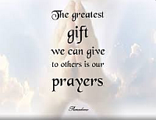
- Call to Worship
- Hymn
- Announcements
- Prayer Requests
- Special Music
- Sermon
From the Pastor
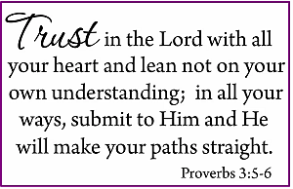
Perfect means “without flaw.” God is perfect in every way. He is flawless. “He is the Rock, His works are perfect, and all His ways are just. A faithful God who does no wrong, upright and just is He” (Deut. 32:4). Psalm 18:30 says that all God does and says is perfect: “As for God, His way is perfect: The LORD’s word is flawless; He shields all who take refuge in him.” God’s perfection is seen in His character, His Word, and His actions. When we evaluate some of God’s actions from our own perspective, we can unwittingly set ourselves in judgment of God. That is a dangerous position because God is our judge; we are not His. We must relinquish our perceived right to adjudge and approve of God’s methods. When we begin our quest for understanding with the premise that God is right, we gain greater insight (Proverbs 3:5–6).
Pastor Tony
Church Information
Last Week’s giving:
$1,350+Online $0 = $1,350
Elders
Tony Raker (Pastor)..………………. pastor@graceevfreechurchva.org
Delmas (Moe) Ritenour………………………….. moemar@shentel.net
Finance: Linda Fraley ……………………………….. lindaf12@shentel.net

IT & Media: Rob Moses & Scott Tucker
Bulletin: Rob Moses ………………. admin@graceevfreechurchva.org
Breakfast: Tammy Copeland ……….…tammyscopeland@gmail.com
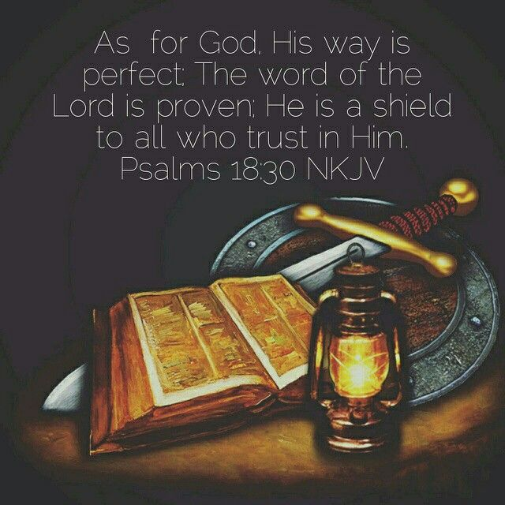
718 E Queen Street, Strasburg, VA 22657, 540-465-4744 msg ph
https://graceevfreechurchva.org
Notes:

