Today’s Service
May 26, 2019
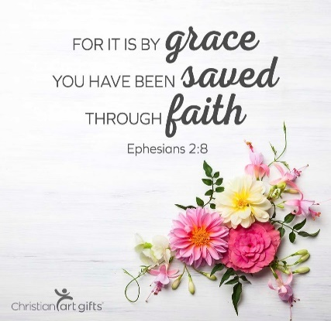
- Call to Worship
- Hymn
- Announcements
- Prayer Requests
- Music
- Sermon
- Offering
From the Pastor
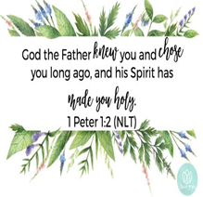
Every human being in the world exists in one of two categories: spiritually dead or spiritually alive. Religion cannot make a dead man live. Good works, effort, and tradition may look like life to other dead people, but they have no spiritual power to transform from the inside out. Jesus Christ paid the highest price to redeem us from the clutches of Satan. Sin destroys; surrender brings life. We were all dead in our trespasses and sins, but we can be made alive through the blood of Jesus Christ our Lord (1 Peter 1:2; Ephesians 2:13). In short because of Jesus, we are not merely bad people made good, but dead people made alive!
Pastor Tony
Church Information
Last Week’s giving: $ 110 Month to date: $ 3,090
Weekly Goal: $ 875 Previous month: $ 5,270
2019 Weekly Average: $ 1,199 Monthly Goal: $ 3,500
Elders
Tony Raker (Pastor)..……………………........... tonyraker@yahoo.com
Delmas (Moe) Ritenour ………………………….. moemar@shentel.net
Finance: Anthony Sinecoff………………………….. sinecoff@gmail.com
Linda Fraley ……………………………….. lindaf12@shentel.net

Media: Rob Moses & Scott Tucker
Bulletin: Rob Moses ………………. admin@graceevfreechurchva.org
Breakfast: Tammy Copeland ……….…tammyscopeland@gmail.com
Adult Sunday School 9:45 am…………………………………….. Linda Fraley
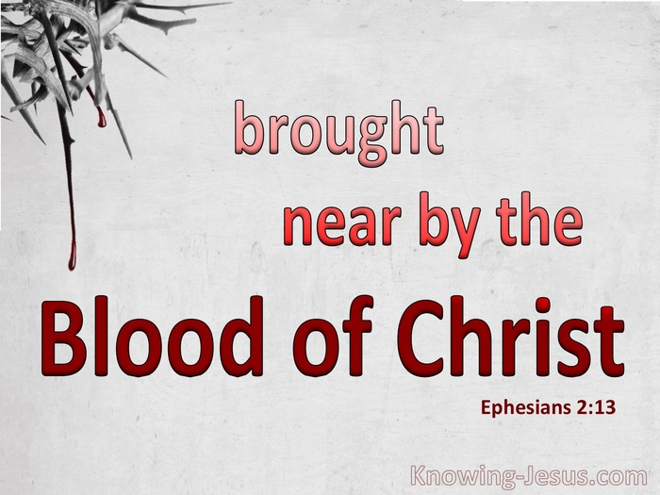
Grace Evangelical Free Church
718 E Queen Street, Strasburg, VA 22657, 540-465-4744 msg ph
https://graceevfreechurchva.org
Please turn off or mute cell phones
Notes:

Next Breakfast is June 15th

