Today’s Service
May 5, 2019
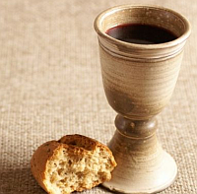
- Call to Worship
- Hymn
- Announcements
- Prayer Requests
- Music
- Sermon
- Communion
- Offering
From the Pastor
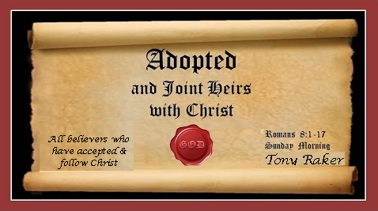
In Romans 8:17 Paul says, “Now if we are children, then we are heirs—heirs of God and co-heirs with Christ, if indeed we share in his sufferings in order that we may also share in his glory.” According to this verse, we share in the sufferings of Christ now and will share in the glory of Christ later as His “co-heirs” or “joint-heirs.” The phrase ‘heirs of God’ emphasizes our relationship to God the Father. As His children, we have “an inheritance that can never perish, spoil or fade . . . kept in heaven” (1 Peter 1:4). The Greek term translated “heirs” in Romans 8:17 refers to “those who receive their allotted possession by right of sonship.” In other words, because God has made us His children (John 1:12), we have full rights to receive His inheritance. We are His beneficiaries (Mt. 25:34; Gal. 3:29; Col. 1:12; 3:24).
Pastor Tony
Church Information
Last Week’s giving: $ 1,410 Month to date: $ 5,270
Weekly Goal: $ 875 Previous month: $ 7,343
2019 Weekly Average: $ 1,229 Monthly Goal: $ 3,500
Elders
Tony Raker (Pastor)..……………………........... tonyraker@yahoo.com
Delmas (Moe) Ritenour ………………………….. moemar@shentel.net
Finance: Anthony Sinecoff………………………….. sinecoff@gmail.com
Linda Fraley ……………………………….. lindaf12@shentel.net

Media: Rob Moses & Scott Tucker
Bulletin: Rob Moses ………………. admin@graceevfreechurchva.org
Breakfast: Tammy Copeland ……….…tammyscopeland@gmail.com
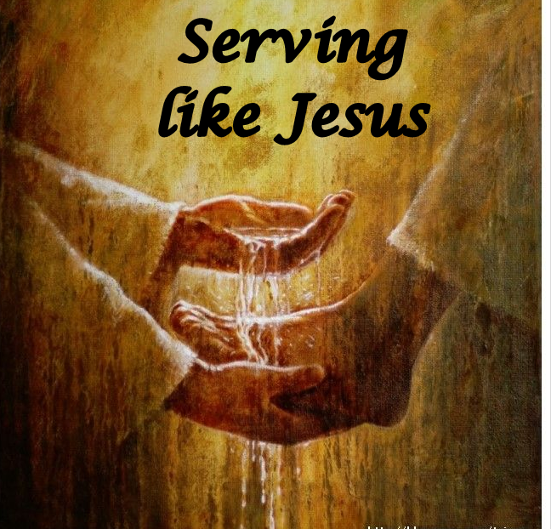
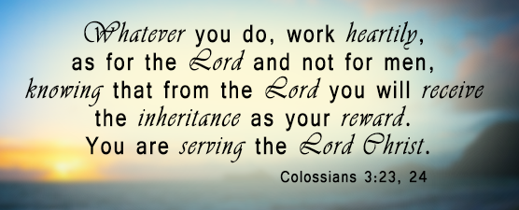
Adult Sunday School 9:45 am…………………………………….. Linda Fraley

Grace Evangelical Free Church
718 E Queen Street, Strasburg, VA 22657, 540-465-4744 msg ph
https://graceevfreechurchva.org
Please turn off or mute cell phones
Notes:

Next Breakfast is May 18th

