Today’s Service
May 9, 2021
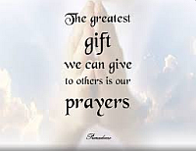
- Call to Worship
- Hymn
- Announcements
- Prayer Requests
- Special Music
- Sermon
From the Pastor
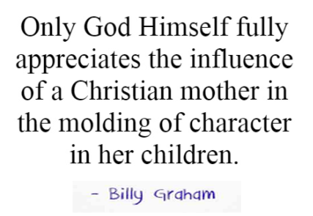
Being a mother is a very important role that the Lord chooses to give. A Christian mother is told to love her children (Titus 2:4-5), in part so that she does not bring reproach on the Lord whose name she bears. Children are a gift from the Lord (Psalm 127:3-5) with the idea that caring for our children, nurturing them, affectionately embracing them, meeting their needs and tenderly befriending each one as a unique gift from the hand of God is His intention. Mothers also play an ongoing role in the lives of their children, whether they are adolescents, teenagers, young adults, or even adults with children of their own as the love, care, nurture and encouragement a mother gives should never cease.
Pastor Tony
Church Information
Last Week’s giving:
$1,212+Online $0 = $1,212
Elders
Tony Raker (Pastor)..………………. pastor@graceevfreechurchva.org
Delmas (Moe) Ritenour………………………….. moemar@shentel.net
Finance: Linda Fraley ……………………………….. lindaf12@shentel.net

IT & Media: Rob Moses & Scott Tucker
Bulletin: Rob Moses ………………. admin@graceevfreechurchva.org
Breakfast: Tammy Copeland ……….…tammyscopeland@gmail.com
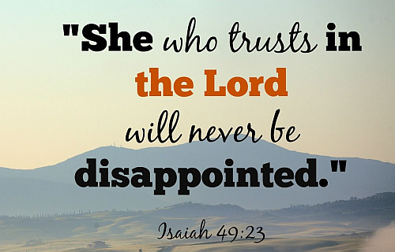
718 E Queen Street, Strasburg, VA 22657, 540-465-4744 msg ph
https://graceevfreechurchva.org
Notes:
Blessed is the woman who trusts in the Lord. Whose hope and joy is found in Him. For she will receive strength to face each day with courage and peace. Leah DiPascal
An encourager at heart, Leah DiPascal has spent more than two decades speaking, writing and introducing others to Jesus.
Leahdipascal.com

