Today’s Service
June 13, 2021
- Call to Worship
- Hymn
- Announcements
- Prayer Requests
- Special Music
- Sermon
- Baby Dedication
From the Pastor
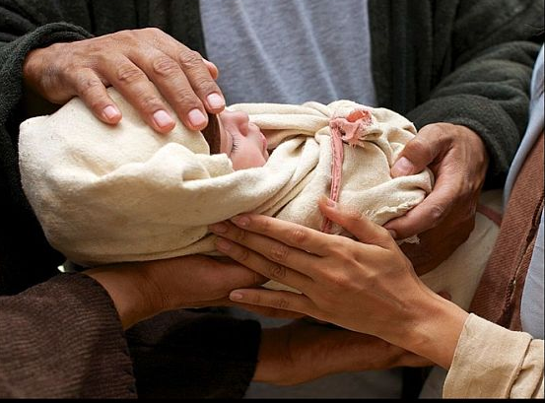
Over the course of His ministry, Jesus often presented children as an example of the type of faith adults are to have. When Jesus blessed the children, He told His disciples, “Truly I tell you, anyone who will not receive the kingdom of God like a little child will never enter it” (Mark 10:15). According to Jesus, the qualities of children that are worthy of emulation are humility and simple acceptance. Jesus wants each of us to possess a childlike faith; that is, a pure, unassuming and humble faith. This straightforward type of faith allows us to receive God’s gift of salvation without pretention or hypocrisy. It allows us to believe unswervingly that God is who He says He is. Like children who rely on their parents’ provision for daily needs, we humbly depend on our Heavenly Father for provision in both the spiritual and physical realms.
Pastor Tony
Church Information
Last Week’s giving:
$2,762 + Online $100 = $2,862
Elders
Tony Raker (Pastor)..………………. pastor@graceevfreechurchva.org
Delmas (Moe) Ritenour………………………….. moemar@shentel.net
Finance: Linda Fraley ……………………………….. lindaf12@shentel.net

IT & Media: Rob Moses & Scott Tucker
Bulletin: Rob Moses ………………. admin@graceevfreechurchva.org
Breakfast: Tammy Copeland ……….…tammyscopeland@gmail.com
The Dedication of Kaetta Sue Davenport
Scripture: Psalm 78:1-8

The parents will answer the following by saying “We do”:

- Do you today recognize this child as a gift of God and give heartfelt thanks for God’s blessing?
- Do you now dedicate Kaetta Sue to the Lord, surrendering all worldly claims upon her life in the hope that she will belong wholly to God upon receiving Jesus as Savior?
- Do you pledge as parents that, with God’s fatherly help, you will bring up Kaetta Sue in the discipline and instruction of the Lord, making every reasonable effort, with patience and love, to build the Word of God, the character of Christ and the joy of the Lord into her life?
- Do you promise to provide, through God’s blessing, for the physical, emotional, intellectual and spiritual needs of Kaetta Sue, looking to your own heavenly Father for the wisdom, love and strength to be an example to her?
- Do you promise, God helping you, to make it your regular prayer that, by God’s grace, Kaetta Sue will come to trust in Jesus Christ alone for the forgiveness of her sins and for the fulfillment of all His promises to her, even eternal life; and in this faith, follow Jesus as Lord and obey His teachings?

The fellowship will answer the following by saying “We will”:

When called upon, will you pledge to support for Erin and Carlos as they endeavor to raise Kaetta Sue in the knowledge and admonition of the Lord? Will you pray for Kaetta Sue and her parents? Will you prove a constant help and blessing to parents and child?
Pastoral Prayer

