Today’s Service
June 16, 2019
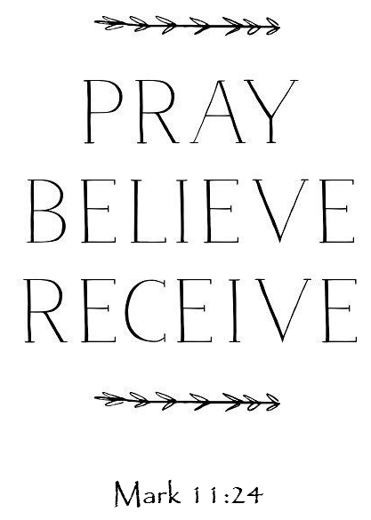
- Call to Worship
- Hymn
- Announcements
- Prayer Requests
- Music
- Sermon
- Offering
From the Pastor
It is important to know God’s will. Jesus said that His true relations are those who know and do the Father’s will (Mark 3:35). God’s will is knowable and provable. Romans 12:2 says, “Do not conform any longer to the pattern of this world, but be transformed by the renewing of your mind. Then you will be able to test and approve what God’s will is—His good, pleasing and perfect will.” This passage gives us an important sequence: the child of God refuses to be conformed to the world and instead allows himself to be transformed by the Spirit. Often, we want God to give us specifics—where to work, where to live, whom to marry, what car to buy, etc. God allows us to make choices, and, if we are yielded to Him, He has ways of preventing wrong choices (see Acts 16:6–7). As your mind is renewed according to the things of God, then you will know God’s perfect will.
Pastor Tony
Church Information
Last Week’s giving: $ 610 Month to date: $ 2,910
Weekly Goal: $ 875 Previous month: $ 3,470
2019 Weekly Average: $ 1,2185 Monthly Goal: $ 3,500
Elders
Tony Raker (Pastor)..……………………........... tonyraker@yahoo.com
Delmas (Moe) Ritenour ………………………….. moemar@shentel.net
Finance: Anthony Sinecoff………………………….. sinecoff@gmail.com
Linda Fraley ……………………………….. lindaf12@shentel.net

Media: Rob Moses & Scott Tucker
Bulletin: Rob Moses ………………. admin@graceevfreechurchva.org
Breakfast: Tammy Copeland ……….…tammyscopeland@gmail.com
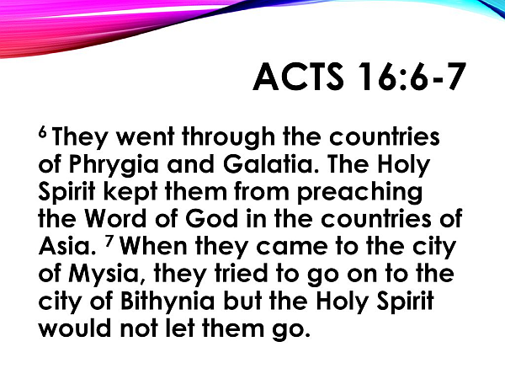
Adult Sunday School 9:45 am…………………………………….. Linda Fraley

Grace Evangelical Free Church
718 E Queen Street, Strasburg, VA 22657, 540-465-4744 msg ph
https://graceevfreechurchva.org
Please turn off or mute cell phones
Notes:

Next Breakfast is July 20th

