Today’s Service
June 20, 2021
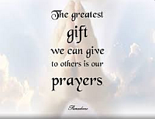
- Call to Worship
- Hymn
- Announcements
- Prayer Requests
- Special Music
- Sermon
From the Pastor
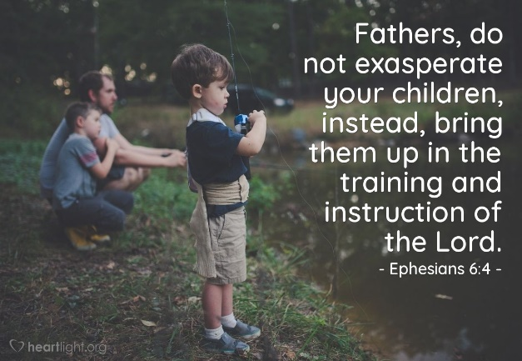
Western culture has become a fatherless realm, and social/political chaos, crime and addiction are some of the results. Fathers who invest time, converse with, and fairly discipline their children are helping secure a healthy future for them. Little eyes are always watching Dad, and whatever fathers excuse in moderation, children will abuse in excess. Fathers who pray in front of their children, honor the Lord in their free time, attend church regularly, read the Bible and give to others teach their children that God is important – meeting Ephesians 6:4
Children should know that with Dad they will be safe, loved and guided toward God’s plan for them.
Pastor Tony
Church Information
Elders
Tony Raker (Pastor)..………………. pastor@graceevfreechurchva.org
Delmas (Moe) Ritenour………………………….. moemar@shentel.net
Finance: Linda Fraley ……………………………….. lindaf12@shentel.net

IT & Media: Rob Moses & Scott Tucker
Bulletin: Rob Moses ………………. admin@graceevfreechurchva.org
Breakfast: Tammy Copeland ……….…tammyscopeland@gmail.com

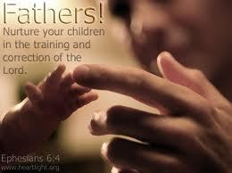
718 E Queen Street, Strasburg, VA 22657, 540-465-4744 msg ph
https://graceevfreechurchva.org
Notes:

Mute cell phone

Bulletin by Rob Moses

