Today’s Service
June 23, 2019
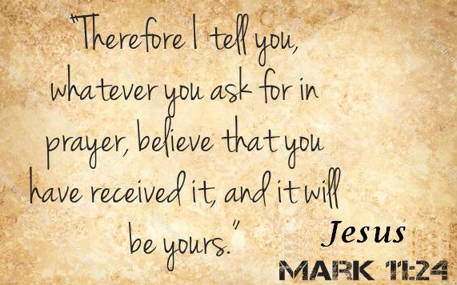
- Call to Worship
- Hymn
- Announcements
- Prayer Requests
- Music
- Sermon
- Offering
From the Pastor
Addiction refers not only to dependency on a habit-forming substance (drugs; alcohol), but also to habitual or compulsive behavior (sports; work; shopping). Given both supersede the priority of God in our lives (1 Corinthians 6:19, 20), an addiction to anything other than God Himself is wrong. God is the only thing which should occupy us habitually. To do so with anything else draws us away from God. Remember: only He alone is worthy of our complete attention, love, and service. To offer these things to anything or anyone else is idolatry. Pastor Tony
Church Information
Last Week’s giving: $ 1,280 Month to date: $ 4,190
Weekly Goal: $ 875 Previous month: $ 3,470
2019 Weekly Average: $ 1,189 Monthly Goal: $ 3,500
Elders
Tony Raker (Pastor)..……………………........... tonyraker@yahoo.com
Delmas (Moe) Ritenour ………………………….. moemar@shentel.net
Finance: Anthony Sinecoff………………………….. sinecoff@gmail.com
Linda Fraley ……………………………….. lindaf12@shentel.net

Media: Rob Moses & Scott Tucker
Bulletin: Rob Moses ………………. admin@graceevfreechurchva.org
Breakfast: Tammy Copeland ……….…tammyscopeland@gmail.com
Adult Sunday School 9:45 am…………………………………….. Linda Fraley
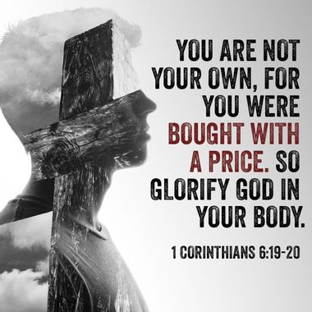
Grace Evangelical Free Church
718 E Queen Street, Strasburg, VA 22657, 540-465-4744 msg ph
https://graceevfreechurchva.org
Please turn off or mute cell phones
Notes:

Next Breakfast is July 20th

