Today’s Service
June 27, 2021
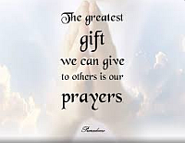
- Call to Worship
- Hymn
- Announcements
- Prayer Requests
- Special Music
- Sermon
From the Pastor
The word backslide, in a Christian context, implies movement away from Christ rather than toward Him. In Mark 14:27 Jesus tells His disciples, “You will all fall away.” What He meant was that, when He was arrested, they would experience a crisis of faith, a life event so shocking that they would run from Jesus and question the very core of their beliefs. It was a night of offense, a night of stumbling for them. But this was a temporary condition. Three days later, Jesus rose from the dead and appeared to the disciples. Their faith and hope were restored, stronger than ever. Salvation comes by means of a genuine confession of Jesus as Lord to a heart that believes in Jesus’ death and resurrection (Romans 10:9–10). If a person who has been truly saved later backslides—that is, he slips back into spiritually damaging attitudes and behaviors—the slide will be temporary. The chastening of the Lord will bring him back (see Hebrews 12:4–13). The Good Shepherd will seek out the wandering lamb (Luke 15:3–7).
Pastor Tony
Church Information

Last Week’s giving: $1,637
Elders
Tony Raker (Pastor)..………………. pastor@graceevfreechurchva.org
Delmas (Moe) Ritenour………………………….. moemar@shentel.net
Finance: Linda Fraley ……………………………….. lindaf12@shentel.net

IT & Media: Rob Moses & Scott Tucker
Bulletin: Rob Moses ………………. admin@graceevfreechurchva.org
Breakfast: Tammy Copeland ……….…tammyscopeland@gmail.com
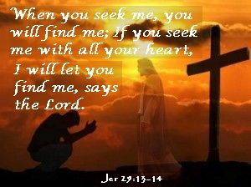

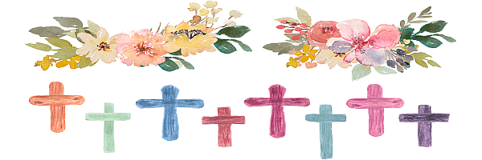
718 E Queen Street, Strasburg, VA 22657, 540-465-4744 msg ph
https://graceevfreechurchva.org
Notes:

Mute cell phone

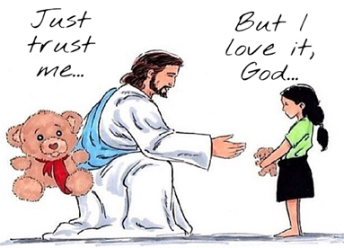
Bulletin by Rob Moses

