Today’s Service
June 30, 2019
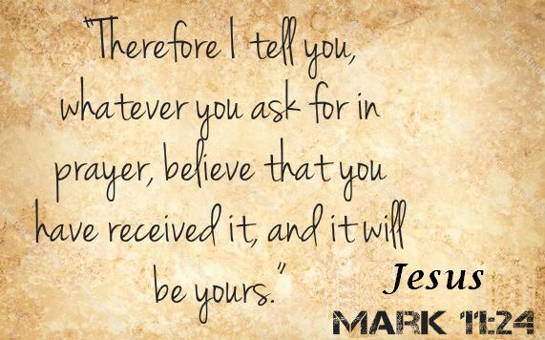
- Call to Worship
- Hymn
- Announcements
- Prayer Requests
- Music
- Sermon
- Offering
From the Pastor
True worship is God-centered worship. People tend to get caught up in where they should worship, what music they should sing in worship, and how their worship looks to other people. Focusing on these things misses the point. Jesus tells us that true worshipers will worship God in spirit and in truth (John 4:24). This means we worship from the heart and the way God has designed. Worship includes praying, reading God's Word with an open heart, singing, participating in communion, and serving others. It is not limited to one act, but is done properly when the heart and attitude of the person (and the congregation) are in the right place in accordance with God’s expectation as expressed in His Word.
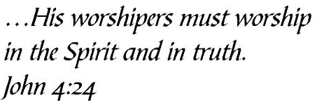
. Pastor Tony

Church Information
Last Week’s giving: $ 1,150 Month to date: $ 5,340
Weekly Goal: $ 875 Previous month: $ 3,470
2019 Weekly Average: $ 1,188 Monthly Goal: $ 3,500
Elders
Tony Raker (Pastor)..……………………........... tonyraker@yahoo.com
Delmas (Moe) Ritenour ………………………….. moemar@shentel.net
Finance: Anthony Sinecoff………………………….. sinecoff@gmail.com
Linda Fraley ……………………………….. lindaf12@shentel.net

Media: Rob Moses & Scott Tucker
Bulletin: Rob Moses ………………. admin@graceevfreechurchva.org
Breakfast: Tammy Copeland ……….…tammyscopeland@gmail.com
Adult Sunday School 9:45 am…………………………………….. Linda Fraley
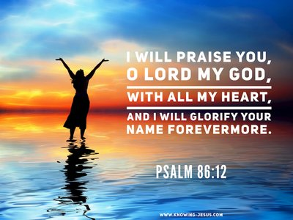
Grace Evangelical Free Church
718 E Queen Street, Strasburg, VA 22657, 540-465-4744 msg ph
https://graceevfreechurchva.org
Please turn off or mute cell phones
Notes:

Next Breakfast is July 20th

