Today’s Service
June 6, 2021
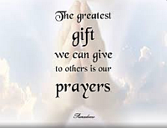
- Call to Worship
- Hymn
- Announcements
- Prayer Requests
- Special Music
- Sermon
From the Pastor
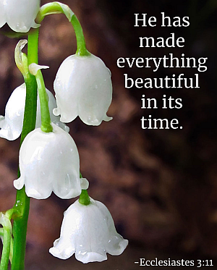
Ecclesiastes 3:11 tells us that God planted eternity in the human heart. This verse explains why we are not satisfied with earthly endeavors and achievements. Humans are born with a deep, inner longing to comprehend our eternal purpose and know our infinite Creator. Through worship, we celebrate God’s presence and power. We grow closer to Him as He speaks to hearts and makes His home in our lives. His will becomes our will, and we are transformed. Not only does worship change us, but it also makes God known to others and changes their lives, too: “He has given me a new song to sing, a hymn of praise to our God. Many will see what he has done and be amazed. They will put their trust in the LORD” (Psalm 40:3). Our worship testifies to what God has done in us and what He can also do for others.
Pastor Tony
Church Information
Last Week’s giving:
$925 + Online $0 = $925
Elders
Tony Raker (Pastor)..………………. pastor@graceevfreechurchva.org
Delmas (Moe) Ritenour………………………….. moemar@shentel.net
Finance: Linda Fraley ……………………………….. lindaf12@shentel.net

IT & Media: Rob Moses & Scott Tucker
Bulletin: Rob Moses ………………. admin@graceevfreechurchva.org
Breakfast: Tammy Copeland ……….…tammyscopeland@gmail.com
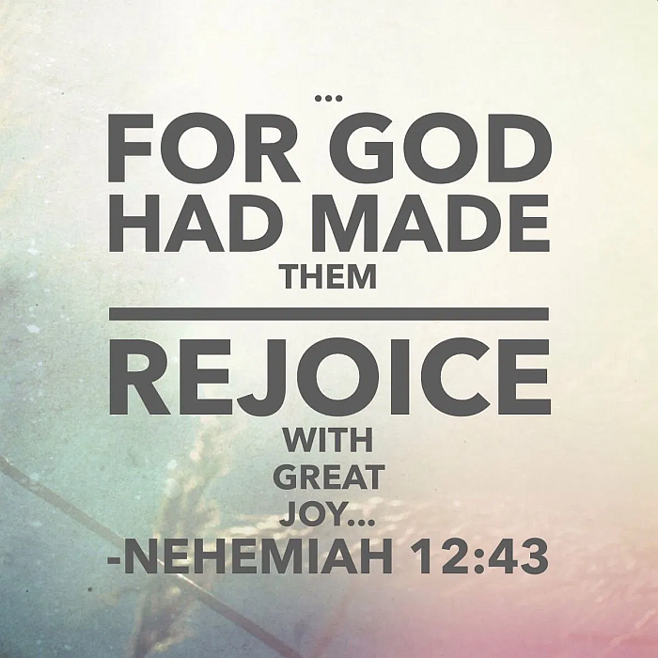

718 E Queen Street, Strasburg, VA 22657, 540-465-4744 msg ph
https://graceevfreechurchva.org
Notes:

Mute cell phone

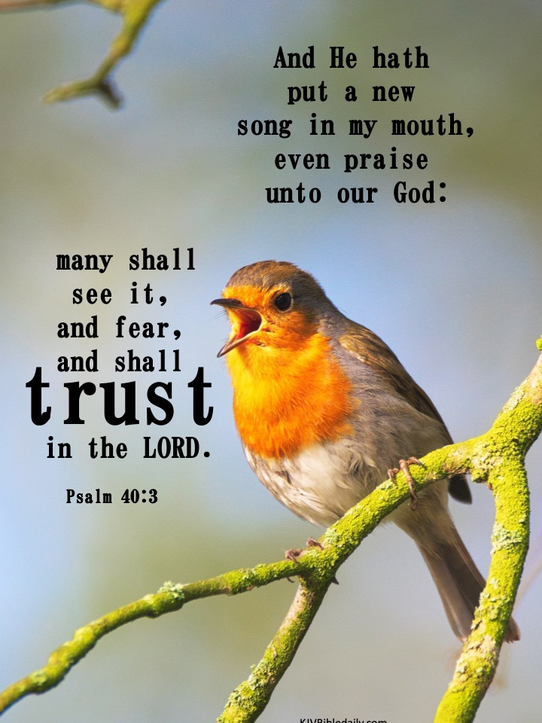
Bulletin by Rob Moses

