Today’s Service
July 10, 2021
- Call to Worship
- Hymn
- Announcements
- Prayer Requests
- Special Music
- Sermon
From the Pastor
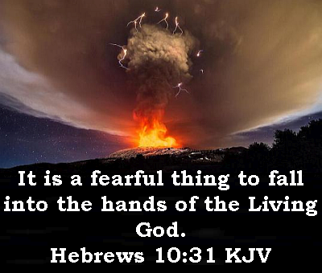
For the unbeliever, the fear of God is the fear of the judgment of God and everlasting death, which is everlasting separation from God (Luke 12:5; Hebrews 10:31). For the believer, the fear of God is something much different. The believer's fear is reverence of God (Hebrews 12:28-29), seeking to live our lives in such a way that pleases Him. When we fail to do so, we invite God’s discipline: an often-ignored fact of life for believers. We complain about our circumstances without realizing that they are the consequences of our own sin and part of the Lord's loving and gracious discipline for that sin. Remember, the Lord's discipline works for our own good, that He might be glorified with our lives (1 Peter 1:15-16).
Pastor Tony
Church Information
Last Week’s Giving: $1,657
Elders
Tony Raker (Pastor)..………………. pastor@graceevfreechurchva.org
Delmas (Moe) Ritenour………………………….. moemar@shentel.net
Finance: Linda Fraley ……………………………….. lindaf12@shentel.net

IT & Media: Rob Moses & Scott Tucker
Bulletin: Rob Moses ………………. admin@graceevfreechurchva.org
Breakfast: Tammy Copeland ……….…tammyscopeland@gmail.com
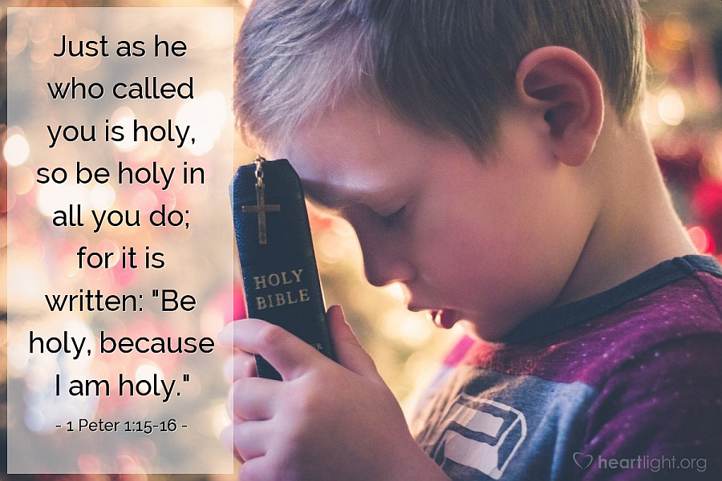

718 E Queen Street, Strasburg, VA 22657, 540-465-4744 msg ph
https://graceevfreechurchva.org
Notes:

Mute cell phone

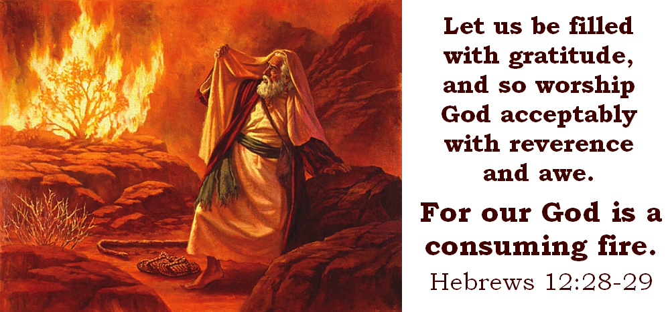
Bulletin by Rob Moses

