Today’s Service
July 4, 2021
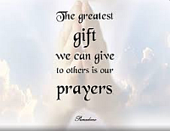
- Call to Worship
- Hymn
- Announcements
- Prayer Requests
- Special Music
- Sermon
- Communion
From the Pastor
As Jesus opened His first sermon (Matthew 5:3–12), He described a series of blessings granted to true servants of God: the eighth beatitude Jesus declared, “Blessed are those who are persecuted for righteousness’ sake, for theirs is the kingdom of heaven” (v 10). True believers in Christ are righteous in God’s eyes (Rom. 3:21–22). Our confession of faith in Jesus Christ and the righteous way we live our lives proves offensive to the world, resulting in persecution for righteousness’ sake. Jesus faced persecution and was hated by the world, and so will all those who belong to Christ and boldly live for Him: “If you belonged to the world, it would love you as its own. As it is, you do not belong to the world, but I have chosen you out of the world. That is why the world hates you” (John 15:19).
Pastor Tony
Church Information
Last week’s giving: $1,911
Elders
Tony Raker (Pastor)..………………. pastor@graceevfreechurchva.org
Delmas (Moe) Ritenour………………………….. moemar@shentel.net
Finance: Linda Fraley ……………………………….. lindaf12@shentel.net

IT & Media: Rob Moses & Scott Tucker
Bulletin: Rob Moses ………………. admin@graceevfreechurchva.org
Breakfast: Tammy Copeland ……….…tammyscopeland@gmail.com

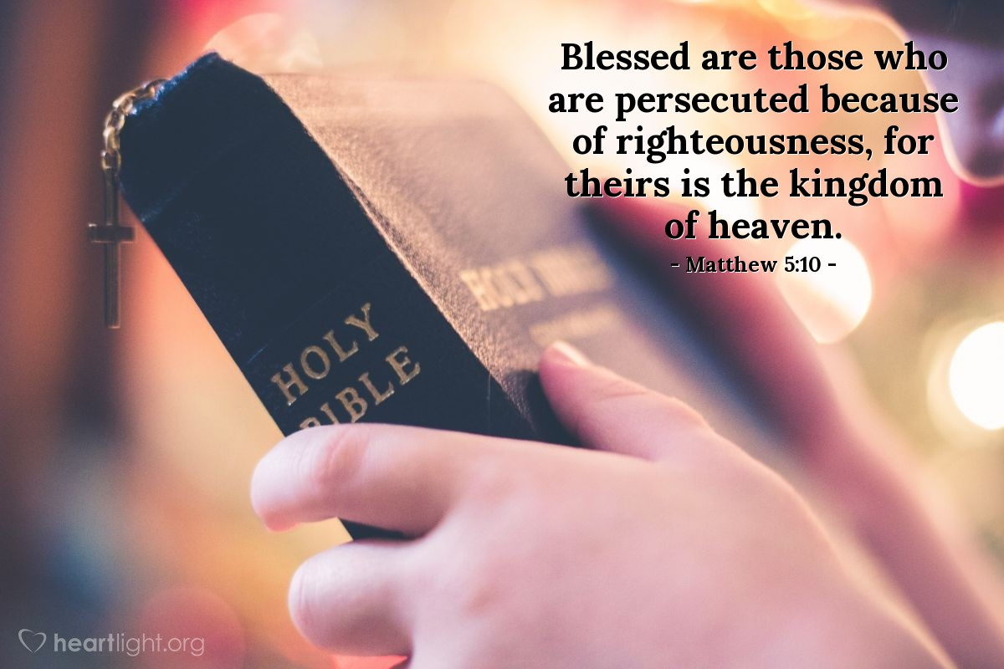

718 E Queen Street, Strasburg, VA 22657, 540-465-4744 msg ph
https://graceevfreechurchva.org
Notes:

Mute cell phone

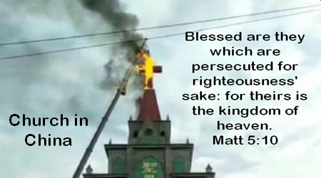
Bulletin by Rob Moses

