Today’s Service
July 7, 2019
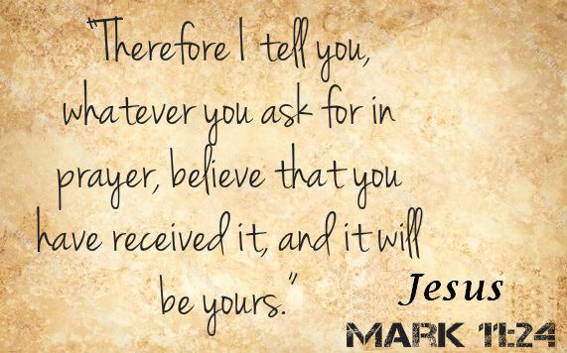
- Call to Worship
- Hymn
- Announcements
- Prayer Requests
- Music
- Sermon
- Communion
- Offering
From the Pastor
We can have thankful hearts toward God even when we do not feel thankful for the circumstance. We can grieve and still be thankful. We can hurt and still be thankful. We can be angry at sin and still be thankful toward God. That is what the Bible calls a “sacrifice of praise” (Hebrews 13:15). Giving thanks to God keeps our hearts in right relationship with Him and saves us from a host of harmful emotions and attitudes that will rob us of the peace God wants us to experience (Philippians 4:6–7). Truly, in the mist of life there is Christ in the midst. Praise God.
Pastor Tony

Church Information
Last Week’s giving: $ 785 Month to date: $ 6,125
Weekly Goal: $ 875 Previous month: $ 3,470
2019 Weekly Average: $ 1,172 Monthly Goal: $ 3,500
Elders
Tony Raker (Pastor)..……………………........... tonyraker@yahoo.com
Delmas (Moe) Ritenour….………………………….. moemar@shentel.net
Finance: Linda Fraley ……………………………….. lindaf12@shentel.net

Media: Rob Moses & Scott Tucker
Bulletin: Rob Moses ………………. admin@graceevfreechurchva.org
Breakfast: Tammy Copeland ……….…tammyscopeland@gmail.com
Adult Sunday School 9:45 am…………………………………….. Linda Fraley
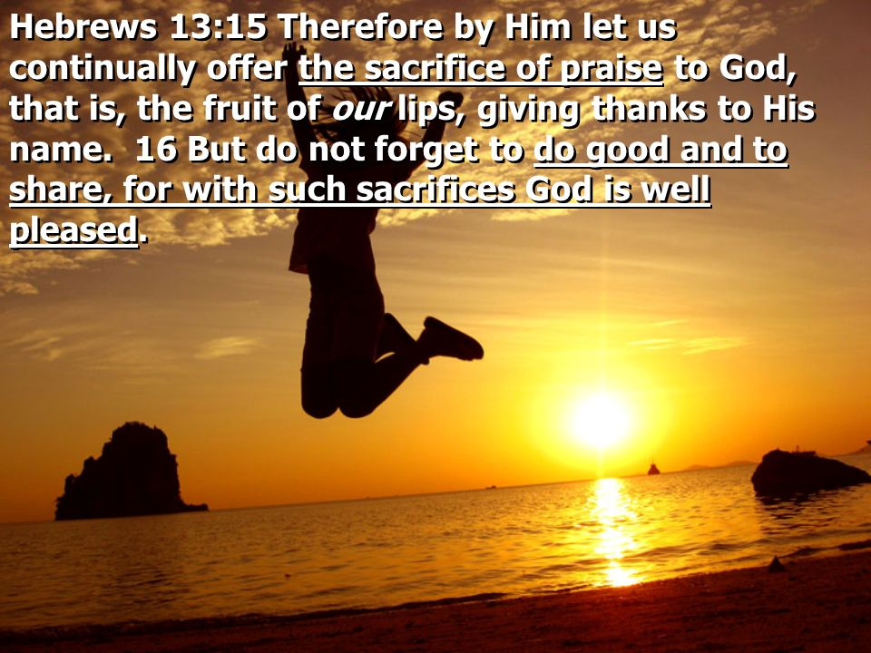
Grace Evangelical Free Church
718 E Queen Street, Strasburg, VA 22657, 540-465-4744 msg ph
https://graceevfreechurchva.org
Please turn off or mute cell phones
Notes:

Next Breakfast is July 20th

