Today’s Service
August 1, 2021
- Call to Worship
- Hymn
- Announcements
- Prayer Requests
- Special Music
- Sermon
From the Pastor
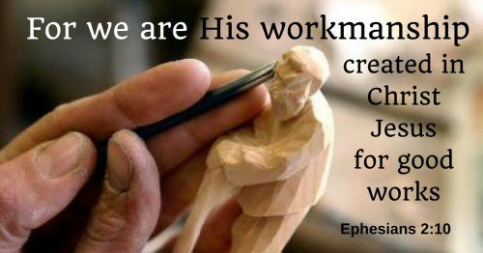
In Jesus’ parable of the talents, he rewarded two faithful servants and said, “Well done, good and faithful servant! You have been faithful with a few things; I will put you in charge of many things. Come and share your master’s happiness!” (Mt. 25:21, 23). Every Christian longs to hear those words from Jesus’ lips someday in heaven. We are saved by grace through faith (Eph. 2:8–9), but we are saved “to do good works” (Eph. 2:10). To hear those words from Jesus, first make sure you are saved. The unbelieving will never hear those words, for “without faith it is impossible to please God” (Heb. 11:6). And recognize that Jesus is not only your Savior; He is also your Lord (Lk. 6:46). So , like Nehemiah: “Serve the LORD with gladness!” (Ps. 100:2).
Pastor Tony
Church Information
Last Week’s Giving: $562
Elders
Tony Raker (Pastor)..………………. pastor@graceevfreechurchva.org
Delmas (Moe) Ritenour………………………….. moemar@shentel.net
Finance: Linda Fraley ……………………………….. lindaf12@shentel.net

IT & Media: Rob Moses & Scott Tucker
Bulletin: Rob Moses ………………. admin@graceevfreechurchva.org
Breakfast: Tammy Copeland ……….…tammyscopeland@gmail.com
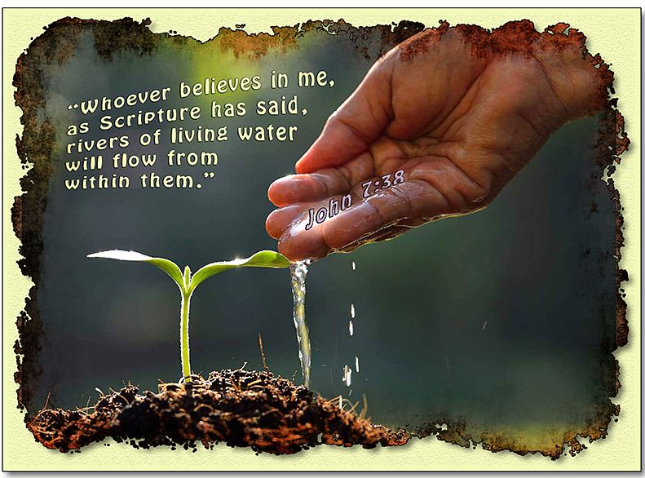
718 E Queen Street, Strasburg, VA 22657, 540-465-4744 msg ph
https://graceevfreechurchva.org
Notes:

Mute cell phone
Communion next week.

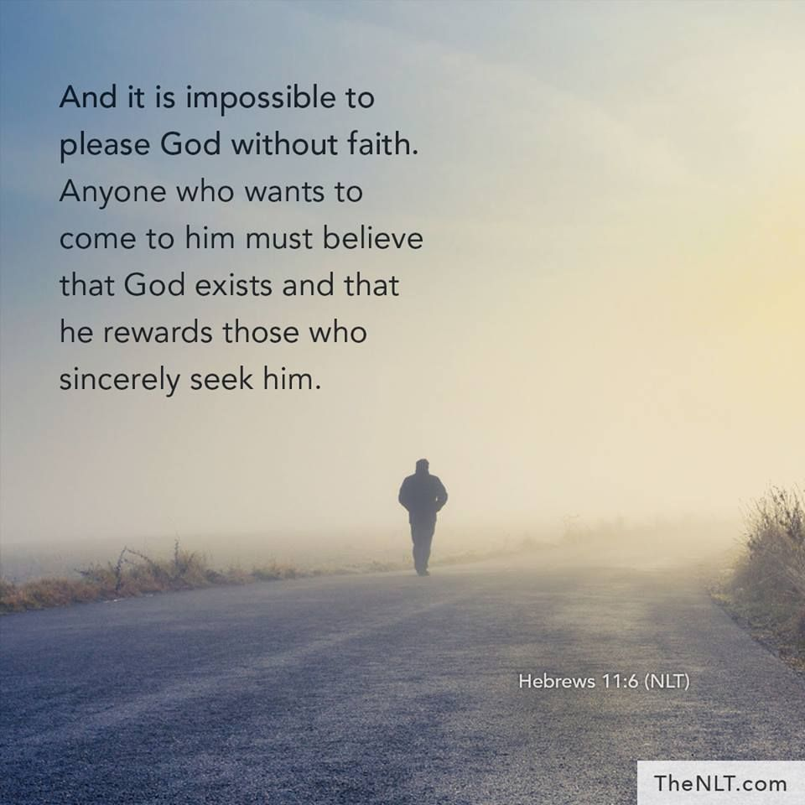
Bulletin by Rob Moses

