Today’s Service
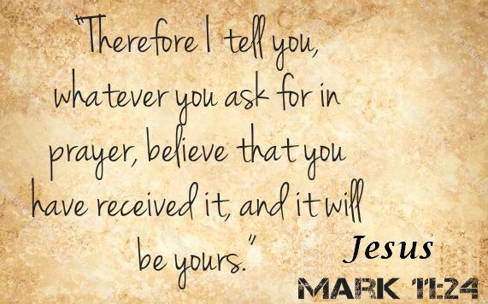
August 18, 2019
- Call to Worship
- Hymn
- Announcements
- Prayer Requests
- Music
- Sermon
- Offering
From the Pastor
Is it really necessary to serve God? What is the purpose of changing our priorities to accomplish tasks that God could honestly do better and more quickly without us? Peter addresses the importance of serving God in 1 Peter 4:10-11: “Each one should use whatever gift he has received to serve others, faithfully administering God's grace in its various forms. If anyone speaks, he should do it as one speaking the very words of God. If anyone serves, he should do it with the strength God provides, so that in all things God may be praised through Jesus Christ. To him be the glory and the power for ever and ever. Amen.” Peter makes it clear that we have received our gifts from God for two purposes— to serve others and to bring praise to God. So, serving isn’t about us receiving attention or glory; it is about us paying attention and giving glory to whom it is due. Measuring up?
Pastor Tony
Church Information
Last Week’s giving: $ 180 Month to date: $ 2,910
Weekly Goal: $ 1,200 Previous month: $ 4,370
2019 Weekly Average: $ 1,180
Elders
Tony Raker (Pastor)..……………………........... tonyraker@yahoo.com
Delmas (Moe) Ritenour….………………………….. moemar@shentel.net
Finance: Linda Fraley ……………………………….. lindaf12@shentel.net

IT & Media: Rob Moses & Scott Tucker
Bulletin: Rob Moses ………………. admin@graceevfreechurchva.org
Breakfast: Tammy Copeland ……….…tammyscopeland@gmail.com
Adult Sunday School 9:45 am…………………………………….. Linda Fraley
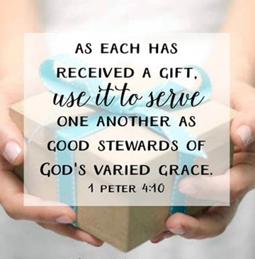
Grace Evangelical Free Church
718 E Queen Street, Strasburg, VA 22657, 540-465-4744 msg ph
https://graceevfreechurchva.org
Please turn off or mute cell phones
Notes:

!

