Today’s Service
August 22, 2021
- Call to Worship
- Hymn
- Announcements
- Prayer Requests
- Special Music
- Sermon
From the Pastor
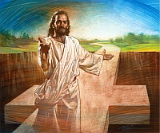
Unlike the question "Does God exist?" very few people question whether Jesus Christ existed; rather, they question who He was. Why is the question over Jesus' true identity, as to whether He was God or not, so important? The most important reason that Jesus has to be God is that if He is not God, His death would not have been sufficient to pay the penalty for the sins of the whole world (1 John 2:2). Only God could pay such an infinite penalty (Romans 5:8; 2 Corinthians 5:21). Jesus had to be God so that He could pay our debt. Jesus had to be a man so He could shed His innocent blood and die. Salvation is available only through faith in Jesus Christ. Jesus' deity is why He is the only way of salvation: "I am the way and the truth and the life. No one comes to the Father except through me" (John 14:6).
Pastor Tony
Church Information
Last Week’s Giving: $576+$300=$876
Elders
Tony Raker (Pastor)..………………. pastor@graceevfreechurchva.org
Delmas (Moe) Ritenour………………………….. moemar@shentel.net
Finance: Linda Fraley ……………………………….. lindaf12@shentel.net

IT & Media: Rob Moses & Scott Tucker
Bulletin: Rob Moses ………………. admin@graceevfreechurchva.org
Breakfast: Tammy Copeland ……….…tammyscopeland@gmail.com
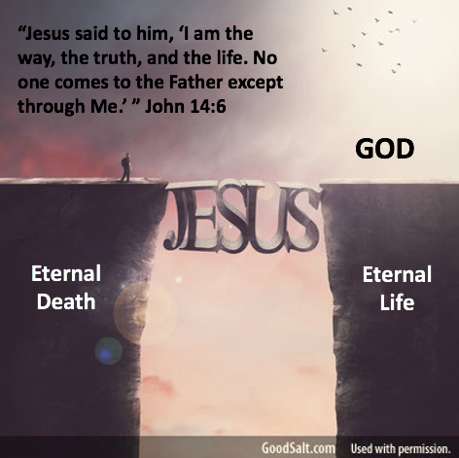
718 E Queen Street, Strasburg, VA 22657, 540-465-4744 msg ph
https://graceevfreechurchva.org
Notes:

Mute cell phone

Bulletin by Rob Moses 2021

