Today’s Service
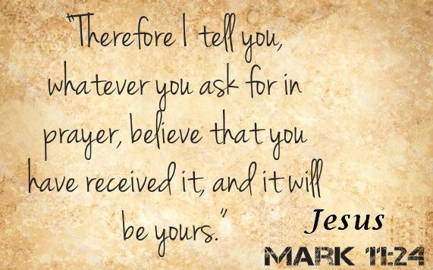
August 25, 2019
- Call to Worship
- Hymn
- Announcements
- Prayer Requests
- Music
- Sermon
- Offering
From the Pastor
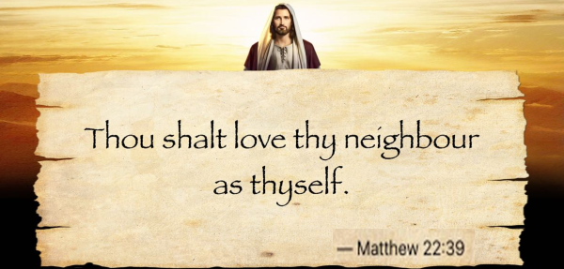
Any service that reflects Jesus’ love is “Christian service.” From giving a cup of water (Mark 9:41) to dying for someone (John 15:13), there are as many types of Christian service as there are needs in the world. Very few involve activity within the four walls of the church. The world is in desperate need of Christians willing to show the love of Christ through their actions on the streets and in the neighborhoods we inhabit. Jesus said the second greatest commandment was to love others—not sentimentally, but tangibly (Matthew 22:39). Every action performed out of kindness, powered by the understanding of Christ and His love, is Christian service – being a true witness to the love and sufficiency of Jesus.
Pastor Tony

Church Information
Last Week’s giving: $ 1,280 Month to date: $ 4,190
Weekly Goal: $ 1,200 Previous month: $ 4,370
2019 Weekly Average: $ 1,183
Elders
Tony Raker (Pastor)..……………………........... tonyraker@yahoo.com
Delmas (Moe) Ritenour….………………………….. moemar@shentel.net
Finance: Linda Fraley ……………………………….. lindaf12@shentel.net

IT & Media: Rob Moses & Scott Tucker
Bulletin: Rob Moses ………………. admin@graceevfreechurchva.org
Breakfast: Tammy Copeland ……….…tammyscopeland@gmail.com
Adult Sunday School 9:45 am…………………………………….. Linda Fraley
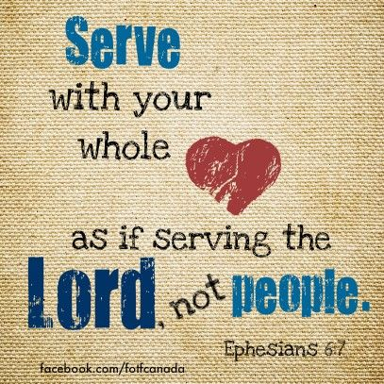
Grace Evangelical Free Church
718 E Queen Street, Strasburg, VA 22657, 540-465-4744 msg ph
https://graceevfreechurchva.org
Please turn off or mute cell phones
Notes:

Next Breakfast 9/21/2019

