Today’s Service
August 29, 2021
- Call to Worship
- Hymn
- Announcements
- Prayer Requests
- Special Music
- Sermon
From the Pastor
Jesus’ desire is that “repentance for the forgiveness of sins will be preached in his name to all nations” (Luke 24:47). The mission field is “all nations;” no geographical restrictions to the gospel, no cultural restrictions and no age restrictions. Children, therefore, should be evangelized. We must also never cause a believing child to stumble (Matthew 18:6) meaning “to entrap, trip up or entice to sin.” The admonition of Proverbs 22:6a is: “Train a child in the way he should go” is Biblical instruction as to their origin, meaning, morality and destiny in Jesus Christ.
Pastor Tony
Church Information
Last Week’s Giving: $301
Elders
Tony Raker (Pastor)..………………. pastor@graceevfreechurchva.org
Delmas (Moe) Ritenour………………………….. moemar@shentel.net
Finance: Linda Fraley ……………………………….. lindaf12@shentel.net

IT & Media: Rob Moses & Scott Tucker
Bulletin: Rob Moses ………………. admin@graceevfreechurchva.org
Breakfast: Tammy Copeland ……….…tammyscopeland@gmail.com
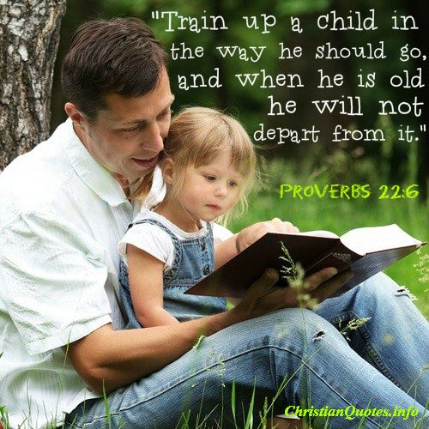
718 E Queen Street, Strasburg, VA 22657, 540-465-4744 msg ph
https://graceevfreechurchva.org
Notes:

Mute cell phone

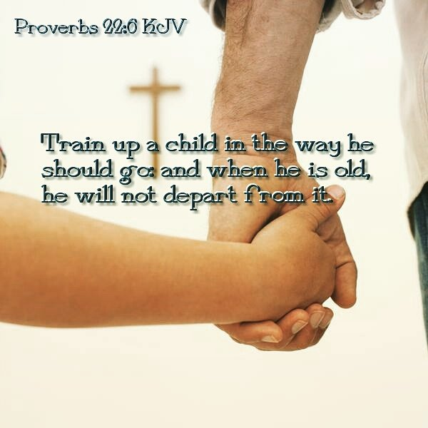
Bulletin by Rob Moses 2021

