Today’s Service
August 4, 2019
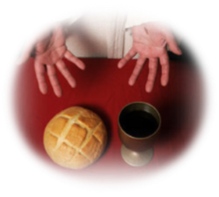
- Call to Worship
- Hymn
- Announcements
- Prayer Requests
- Music
- Sermon
- Communion
- Offering
From the Pastor
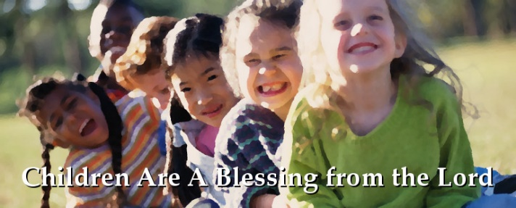
Jesus’ command to “let the little children come to me” (Mt. 19:14) reveals several truths: 1) children need to be blessed by the Lord; 2) the Lord wants to bless children; 3) parents should be encouraged to bring their children to Jesus at an early age and teach them His ways; 4) Jesus has regard for the weakest and most vulnerable among us; 5) no matter how compassionate Jesus’ followers are, Jesus Himself is more compassionate still; 6) those who come to Christ must do so in childlike humility, faith, and simplicity. Children are a blessing of the Lord (Ps. 127:3-5), a sacred trust to be reared expressly by parents (NOT a village) as the church assists via the fellowship of the saints.
Pastor Tony

Church Information
Last Week’s giving: $ 510 Month to date: $ 4,370
Weekly Goal: $ 1,200 Previous month: $ 6,125
2019 Weekly Average: $ 1,162
Elders
Tony Raker (Pastor)..……………………........... tonyraker@yahoo.com
Delmas (Moe) Ritenour….………………………….. moemar@shentel.net
Finance: Linda Fraley ……………………………….. lindaf12@shentel.net

IT & Media: Rob Moses & Scott Tucker
Bulletin: Rob Moses ………………. admin@graceevfreechurchva.org
Breakfast: Tammy Copeland ……….…tammyscopeland@gmail.com
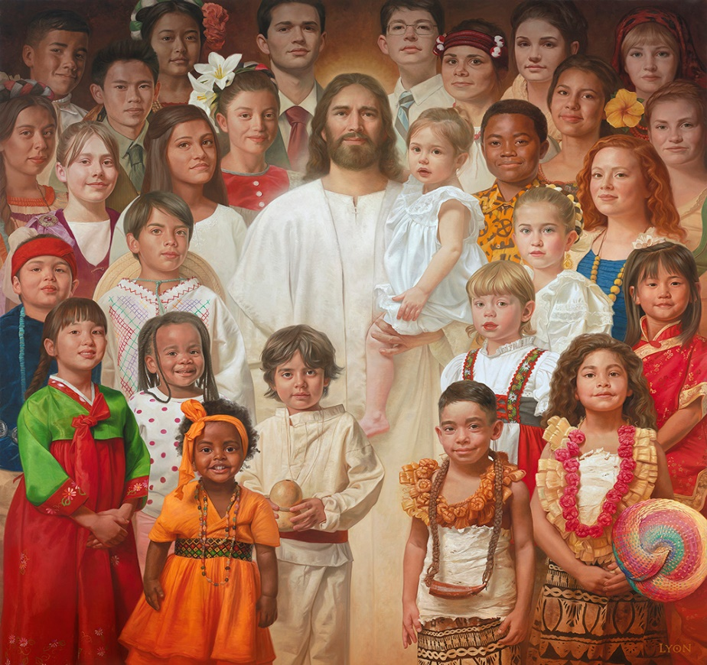
Adult Sunday School 9:45 am…………………………………….. Linda Fraley

Grace Evangelical Free Church
718 E Queen Street, Strasburg, VA 22657, 540-465-4744 msg ph
https://graceevfreechurchva.org
Please turn off or mute cell phones
Notes:

Next Breakfast is August 17th

