Today’s Service
August 8, 2021
- Call to Worship
- Hymn
- Announcements
- Prayer Requests
- Special Music
- Sermon
- Communion
From the Pastor
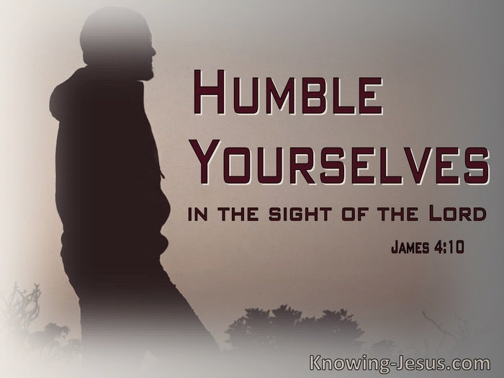
The Bible lavishes praise on the humble. Jesus, of course, modeled humility (Matthew 11:29). Moses was “more humble than any other person” (Numbers 12:3). Paul reminded the Corinthians that, even though he was an apostle and their spiritual elder, he was humble when he was among them (2 Corinthians 10:1). Jesus taught that those who wish to be great must be the most humble (Matthew 23:12). Many places in Scripture command us to humble ourselves (Ephesians 4:2; 1 Peter 3:8; 5:6). If we don’t humble ourselves, God will do it, and that can be even more painful (Luke 1:52; 18:14). A key characteristic to John’s later ministry…and success…was his humbleness allowing God to work through him.
Pastor Tony
Church Information
Last Week’s Giving: $6,511
Elders
Tony Raker (Pastor)..………………. pastor@graceevfreechurchva.org
Delmas (Moe) Ritenour………………………….. moemar@shentel.net
Finance: Linda Fraley ……………………………….. lindaf12@shentel.net

IT & Media: Rob Moses & Scott Tucker
Bulletin: Rob Moses ………………. admin@graceevfreechurchva.org
Breakfast: Tammy Copeland ……….…tammyscopeland@gmail.com
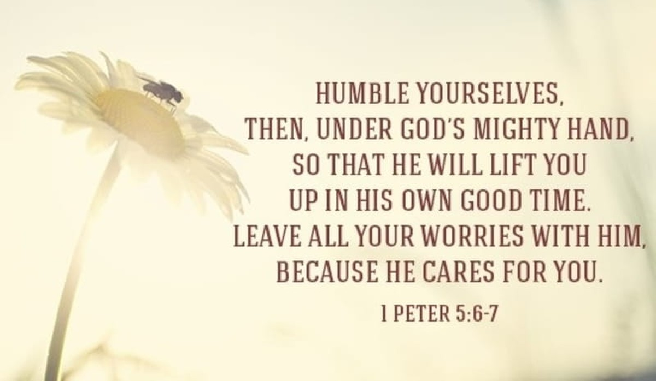
718 E Queen Street, Strasburg, VA 22657, 540-465-4744 msg ph
https://graceevfreechurchva.org
Notes:

Mute cell phone
Communion today

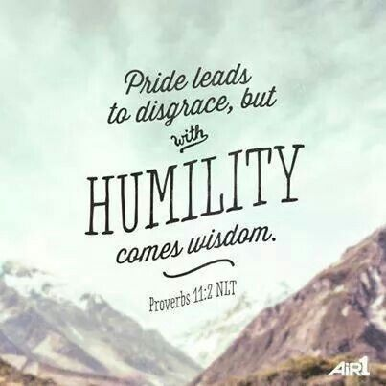
Bulletin by Rob Moses

