Today’s Service
September 19, 2021
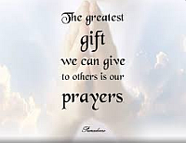
- Call to Worship
- Hymn
- Announcements
- Prayer Requests
- Special Music
- Sermon
From the Pastor
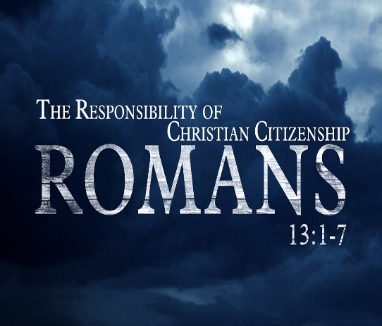
Romans 13:1-7 makes it abundantly clear that we are to obey the government God places over us. God created government to establish order, punish evil, and promote justice (Gen. 9:6; 1 Cor. 14:33; Rom. 12:8). We are to obey the government in everything—paying taxes, obeying rules and laws and showing respect. If we do not, we are ultimately showing disrespect towards God, for He is the One who placed that government over us. When the apostle Paul wrote to the Romans, he was under the government of Rome during the reign of Nero, perhaps the most evil of all the Roman emperors. Paul still recognized the Roman government's rule over him. How can we do any less?
Pastor Tony
Church Information
Last Week’s Giving: $1,545
Elders
Tony Raker (Pastor)..………………. pastor@graceevfreechurchva.org
Delmas (Moe) Ritenour………………………….. moemar@shentel.net
Finance: Linda Fraley ……………………………….. lindaf12@shentel.net

IT & Media: Rob Moses & Scott Tucker
Bulletin: Rob Moses ………………. admin@graceevfreechurchva.org
Breakfast: Tammy Copeland ……….…tammyscopeland@gmail.com
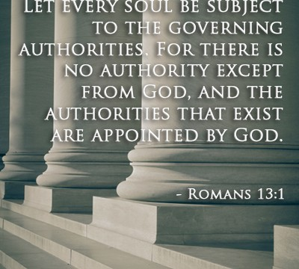
718 E Queen Street, Strasburg, VA 22657, 540-465-4744 msg ph
https://graceevfreechurchva.org
Notes:

Mute cell phone

Oh child. If you only knew what awaits you, you would not be upset. There would be no panic nor anger. If only you knew what I have planned for you, you would not cry. And while your family and friends know you are going to a better place, even they do not fully understand the wonderous existence that I will give you when I bring you home.
Soon you will see and you will forgive me for this upset to your life. Child, I know what is best for you, even if it hurts now. Even if it hurts and causes loss to your family and friends, they should know they will see you again and you will all be far happier where you are going. Child, I am taking you home where you will never feel pain again, where you will be with me forever. Take comfort, my child, for I am bringing you home.
Bulletin by Rob Moses 2021

