Today’s Service
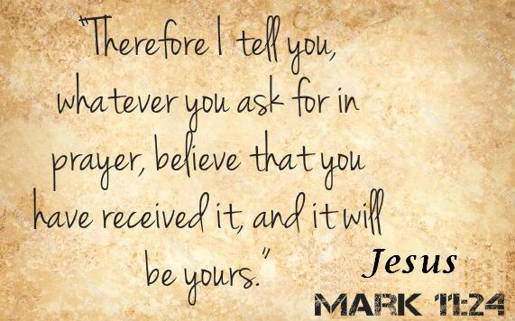
September 22, 2019
- Call to Worship
- Hymn
- Announcements
- Prayer Requests
- Music
- Sermon
- Offering
From the Pastor
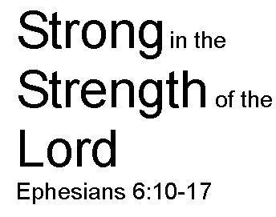
Since believers are engaged in an ongoing spiritual battle with the powers of darkness, they cannot endure without the power of God (Ephesians 6:10). Those who rely on God’s strength from day to day will find in Him a never-ending spring of energy: “Blessed are those whose strength is in you. . . . They go from strength to strength, till each appears before God in Zion” (Psalm 84:5, 7). As God’s children, we are strengthened by His grace (Hebrews 13:9), by our time spent in prayer (Luke 18:1), and by the promise that God will reward our efforts (Galatians 6:9). Many around us may grow weary and faint, but “those who hope in the LORD will renew their strength. They will soar on wings like eagles; they will run and not grow weary, they will walk and not be faint” (Is. 40:31).
Pastor Tony
Church Information
Last Week’s giving: $ 640 Month to date: $ 3,040
Weekly Goal: $ 1,200 Previous month: $ 4,470
2019 Weekly Average: $ 1,145
Elders
Tony Raker (Pastor)..……………………........... tonyraker@yahoo.com
Delmas (Moe) Ritenour….………………………….. moemar@shentel.net
Finance: Linda Fraley ……………………………….. lindaf12@shentel.net

IT & Media: Rob Moses & Scott Tucker
Bulletin: Rob Moses ………………. admin@graceevfreechurchva.org
Breakfast: Tammy Copeland ……….…tammyscopeland@gmail.com
Grace Evangelical Free Church
718 E Queen Street, Strasburg, VA 22657, 540-465-4744 msg ph
https://graceevfreechurchva.org
Please turn off or mute cell phones
Notes:

Next Breakfast 10/19/2019

