Today’s Service
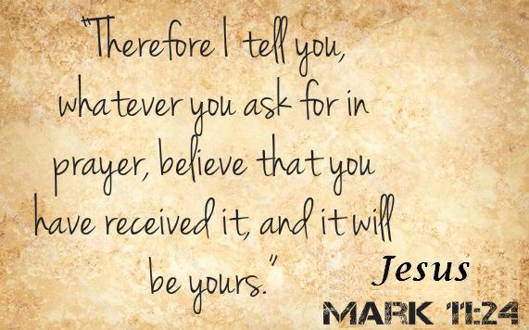
September 8, 2019
- Call to Worship
- Hymn
- Announcements
- Prayer Requests
- Music
- Sermon
- Offering
From the Pastor
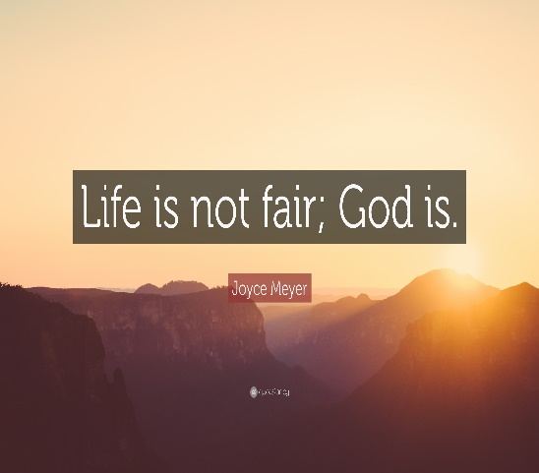
When God draws our hearts and opens our minds, we have the opportunity to respond to the revelation of the creation around us (Psalm 19:1–3) and the conscience within us (Romans 2:15) and turn to God. Those who do not respond will receive what they truly deserve because of their rejection of Him. Their punishment is fair (John 3:18, 36). Those who believe are receiving far better than they deserve. No one, though, is being punished beyond what he or she deserves. Is God fair? Yes. He is also gracious, merciful, and forgiving.
Pastor Tony

Church Information
Last Week’s giving: $ 2,400 Month to date: $ 2,400
Weekly Goal: $ 1,200 Previous month: $ 4,470
2019 Weekly Average: $ 1,192
Elders
Tony Raker (Pastor)..……………………........... tonyraker@yahoo.com
Delmas (Moe) Ritenour….………………………….. moemar@shentel.net
Finance: Linda Fraley ……………………………….. lindaf12@shentel.net

IT & Media: Rob Moses & Scott Tucker
Bulletin: Rob Moses ………………. admin@graceevfreechurchva.org
Breakfast: Tammy Copeland ……….…tammyscopeland@gmail.com
Adult Sunday School 9:45 am…………………………………….. Linda Fraley
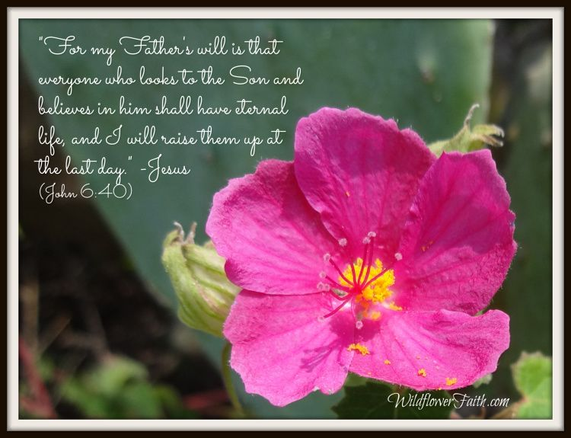
Grace Evangelical Free Church
718 E Queen Street, Strasburg, VA 22657, 540-465-4744 msg ph
https://graceevfreechurchva.org
Please turn off or mute cell phones
Notes:

Next Breakfast 9/21/2019

